Difference between functional components and class components?

Functional components | Class components
Defination  Functional components are written as javascript functions which can take arguments and return JSX, we use hooks inside of these components which itself are basically functions, | Defination  We use ES6 classes, we need to extend them from react. component class, we have a constructor to initialize the object we have a super method to access the constructor of the React class and this keyword,
State declaration  In functional components we can declare multiple state variables using useState hook eg one for name one for avatar etc but if they are updated suppose on a single event react renders the ui only once as reactjs has integrated batch updates, | State declaration  While in class component for one component there is on single source of truth the state object inside of which we declare different variables as key value pairs,
State function  In functional components when we setState,  The functional component is once again called to get the new render tree and it replaces all the calls of useState function with new variable, we never mutate the state variable actually it’s always a fresh function call,  that is why we are able to use const | State function  While when we set state in the class component to update the UI the state variable is mutated as it is inside of an object,  it means it is changing the value in the same variable inside of the state object as it is the property of object,
We don’t have jsx hell in functional component0 | We can have lot of dependency like hoc embedded inside hoc

Virtual Dom
React allows us to write maintainable and performant code by using the concepts of components. Components allows us to focus on describing the UI we want, rather than the details of how the UI gets inserted on the page.
The most expensive thing that we can do with the web browser is to write to the dom, we can create 10000 js objects faster than manipulating the dom ,
we are not only changing content actually web browser has to repaint has to do frame animation it has to load network request it has to do all of this at the same time, javascript is also single threaded it means everything happens from start to finish,
Web page can be think of as any other document like pdf document of google docs where we edit the stuff, in browser we edit the HTML document with an API that API is the DOM.
when a component runs the result is that react creates an instance of the component with states and props, the instance consume its props it deduces its state and returns what its know as an element,
An element is a plain object describing a component or HTML tag, the return statement returns an entity that react internally calls an element
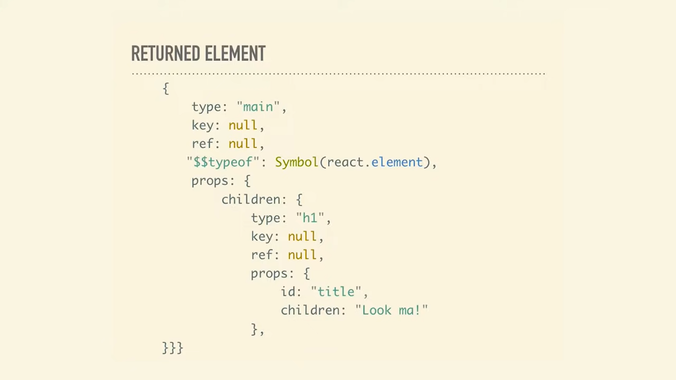
The object has a type property it can be a string reference to an html tag react internally calls it a dom element or it can be reference to a component so if the type is mycomponent or something like that react calls it my component,
The next property is the key this is used when we are manually creating a bunch of children by mapping over an array
Ref is an actual reference to an actual dom node so if we have ever created ref this is where the value ends up
Then we have typeof Symbol which is kind of safety feature for cross site scripting attack, symbol is a built in object whose constructor returns a symbol primitive also called a symbol value or just a symbol,
Then we have the props which are the arguments passed in as attributes it also has a children key which basically the elements inside the Element here we have h1 then again the same thing,
This object and its children going all the way down is what known as a virtual DOM, its really cheap to generate this objects

Creating a virtual DOM is part of the process known as reconciliation , it is responsible for maintaining the tree of elements,
To be efficient we need to tell a way what’s different between the real dom which in the browser and this virtual dom, so that we are only changing things in the DOM that needs to be changed, Reconciliation houses the diffing algorithm that determines what parts of that tree need to be replaced,
Whenever the root of elements have different types react creates the whole tree and it builds whole tree from the scratch and reason for that their type has changed,
In the diagram above if the type of main changes everything beneath gets blown away ,
We are building reusable components so if we have a product list and then we are changing to view an individual product they are not the same thing so react can just make the assumption that instead of calculating states and props we build this new thing, all dom nodes are destroyed component instances will receive component on mount the equivalent useEffect hook fires a new tree with new components are gonna build and start rendering again new dom nodes are inserted to the DOM, any state associated with old tree is lost,
React isin’t realy reusing DOM elements its actually destroying and recreating them every time an element gets generated
We can thing of a element corelating to the DOM node so if the element changes the DOM node changes if the element goes away that dom node goes away,
React makes a distinction between those two types of elements, if in case the classname is changing when finally rerendered the react finds the dom node and just modifies the classname no need to change any thing else because its all the same.
When an component elements updates the instance stays the same it is maintained across rerenders so we still have the same component instance updates the prop of underlying components instance to match this new element we are going to generate so when the render method is called the diff algorithm recurses on the previous result and the new result comparing the new result with the previous to current until the end of the tree until nothing left to change
Lets suppose we have a simple unordered list with two list items and lets say we add another item, react compares the previous first item in the list to the next first item sees that they are the same, second second same
and then previous doesn’t have the third new has the third and react will insert the third item,
By adding keys we can tell react which elements are still the same so that only few dom manipulation occurs as possible, the main goal is to touch the dom as little as possible, with keys in place the the react will use the keys to compare and will result in fewer dom manipulation
The render method from reactDom does the whole reconciliation thing, it generates the virtual dom generate that tree of element and actually insert it into that dom.

Composition
React composition is a development pattern based on react’s original component model where we build components from other components using explicit props of the implicit children prop,
In terms of refactoring, React composition is a pattern that can be used to break a complex component down to smaller component, and then composing those smaller components,
Component composition is the name for passing components as props to other component,
We know the children element of a parent element can be on the children prop of the parent element,
So while composing an element we give it a children prop and then we can utilize that in the jsx ,
When using this element we can just insert another element inside of it with closing tag,
We don’t even need to use composition by defining children we can just pass in a prop and when using the element we can assign the attribute of the prop to the element
This can be powerful when we need to pass data without prop drilling ,
We can have the data in the parent component and then add a component to it via its attribute which is rendered at a particular node and then we can pass the data to component declared inside the attribute as an attribute

How setState works in react,
setState() does not immediately mutate this.state but creates a pending state transition. Accessing this.state after calling this method can potentially return the existing value. There is no guarantee of synchronous operation of calls to setState and calls may be batched for performance gains.
setState is not a web api or an network call but as javascript is single threaded and setState causes rerendering this can be an expensive operation and making it synchronous might leave the UI unresponsive,
in class component this.setState mutates the variable in the state object while in functional component the useState function is called with the new value of state all together when the state value changes
Shallow merging only merges things on the first level though (hence the term shallow), which means that we have to be careful when we use setState( ) on state objects with nested structures.

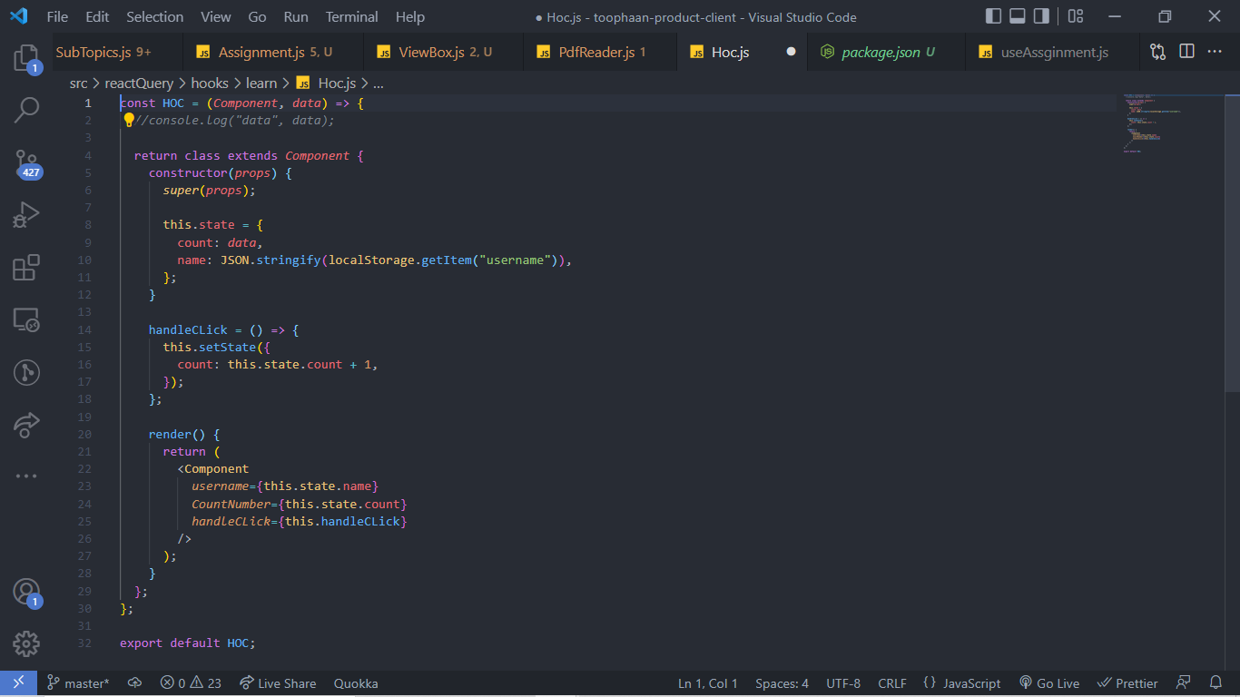
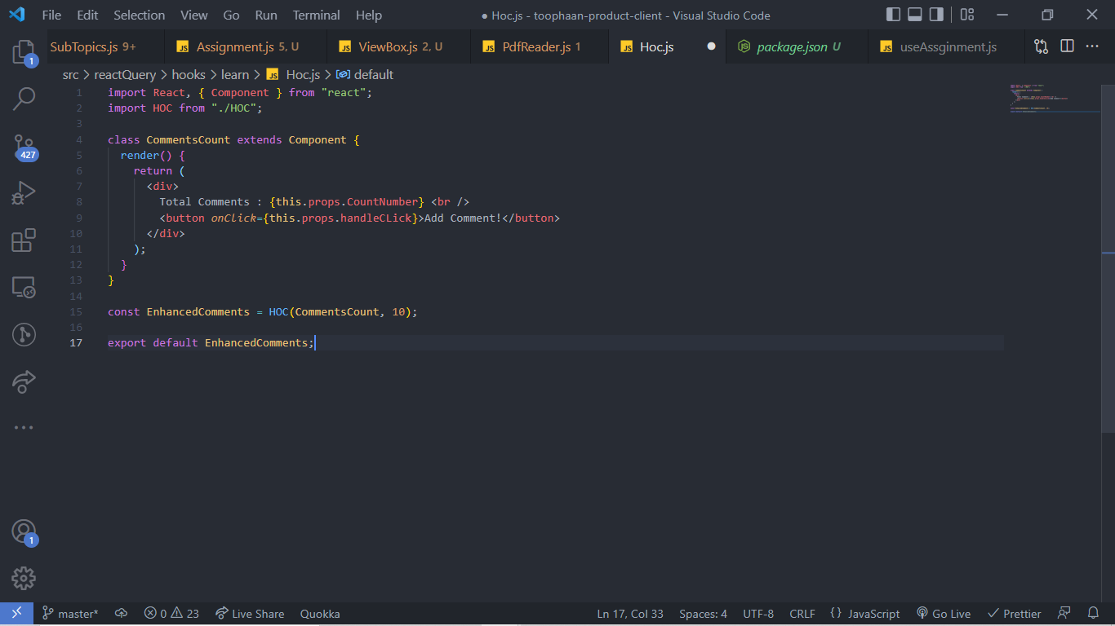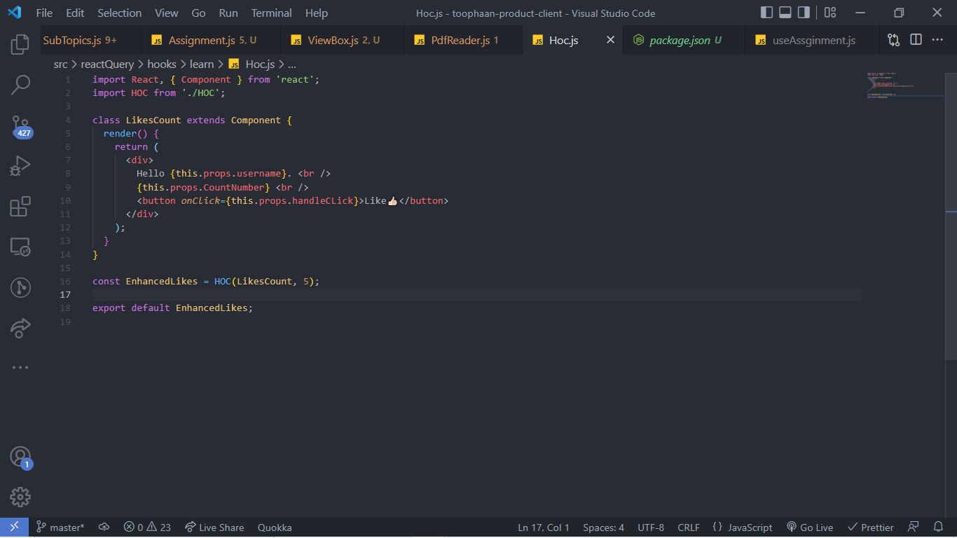
HOC
Sometimes we have to write same logic in diff components, also in fetching data we have to fetch in each component if we don’t use props,
Hoc takes two arguments component and data to returns a new component add some extra functionality to the original component,
when working with class component hoc are the functional component that return the class components,
if two or more components share same logic, as in example like and comments component, we can transfer the common logic to HOC, like here we do of getting the user from local storage and the counter logic, Now in both the likes count component and the comment count component we import the HOC and the create a new enhanced component with extra functionality by passing the component into HOC

How to force rerender
In function components, there's no equivalent of forceUpdate, but you can contrive a way to force updates with the useState hook.
like for example we can write const [rerender, setRerender] useState(‘’) and set it to any primitive value and the change the value with setState when we want to force rerender

Redux
Redux is a pattern and library for managing and updating application state, using events called "actions"

Why Should I Use Redux?
Redux helps us manage "global" state - state that is needed across many parts of our application.
The patterns and tools provided by Redux make it easier to understand when, where, why, and how the state in our application is being updated, and how our application logic will behave when those changes occur.

. When Should I Use Redux?
- When we have large amounts of application state that are needed in many places in the app
- When the app state is updated frequently over time
- When the logic to update that state may be complex
- The app has a medium or large-sized codebase, and might be worked on by many people
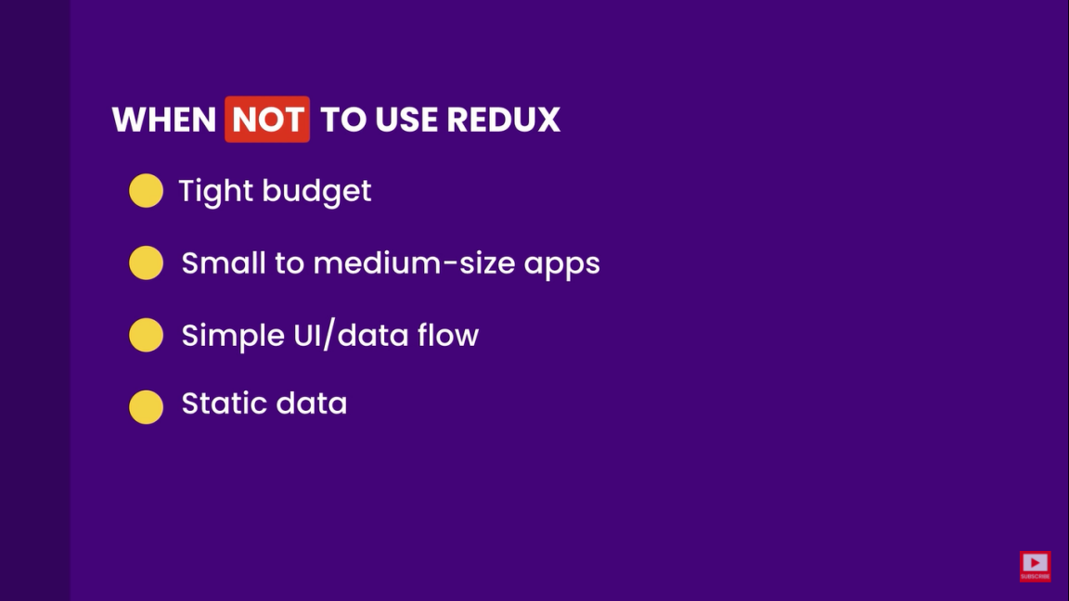
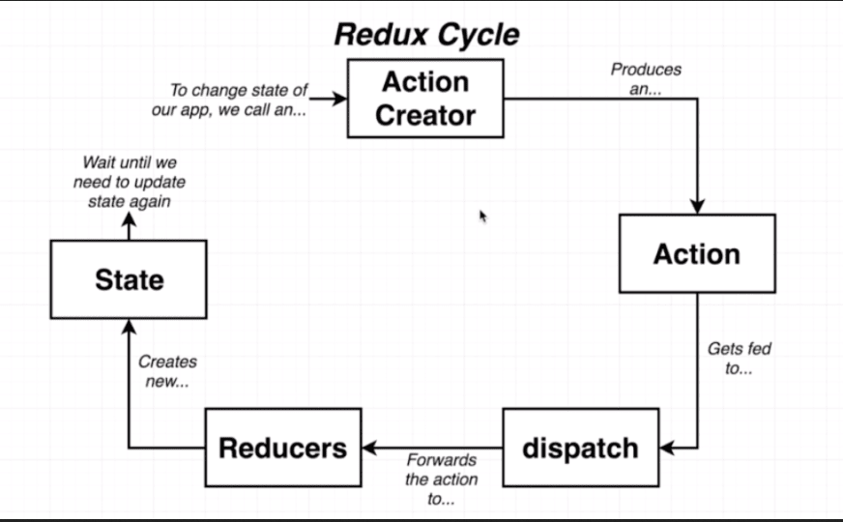
Action creator is a function that returns a plain javascript object called action,
Action is the plain javascript object which has a type property and a payload property, type is the action type and payload is the change we want in our state object,
Dispatch is function that dispatches the action type and payload to our reducers, whenever an action creator is called,
Reducers are functions which take two arguments state and the action, here state is the current state and the action is the payload dispatched from the action,
We can have many reducers but we have single store which has all the data
we wire the reducers through combine reducer call to get all the data inside the store,
To make the store object accessible globally to all components react redux provides a provider and a connect component
the provider wraps the entire app and the store is passed to the provider as props and the connect component is used to access the store and action creators inside of our component where we need to update the state,
Connect component is passed a special function whose name is map state to props by convention which basically maps state to the props of the component, connect is also passed with action creators in the object which is the second argument of the connect,
if we want to use multiple action creators in one component we can use mapDispatchToProps to access the action in the component,
The state is available as the this.props.state and the action is available this.props.aciton
Asyn action creators
The rule that the action creators should only return a plain object so the if we are using a async action creator function unless and until the promise gets resolved it will return the fetch function which is not a plain object and the data send to the reducer now the redux store says it’s not a plain JS object with only a type property

And we get the error actions must be plain objects Use custom middleware for async actions.
By the time our action goes to the reducer we wont have fetched the data
We use a middleware like redux thunk which modifies the action basically it enables us to return the function or a plain javascript object and onto that action it allows us to access the dispatch method and getstate method
Now we can use the dispatch method inside of the function to dispatch the action only when the promise is resolve and we can use getstate to access the data in the state for other utilities like for eg if we want to use id for the async call we can use that

Another way can be to do the axios call inside the component and then send dispatch the action with the plain js object
With hooks react redux provides its own custom hooks such as useReducer and useDispatch
useSelector()
its equivalent to the mapstatetoprops argument to connect conceptually the selector will be called with the entire Redux store state as its only argument, the selector runs whenever the functional component rerenders unless its reference hasn’t changed since a previous rerender of the component so that the cached result can be returned by the hook without rerunning the selector
however when an action is dispatched to the redux store useSelector() only forces a rerender if the selector result appears to be different than the last result
useSelector hook recieves a function that takes the first argument state and returns the calculated result which we can specify in the function itself,
reducer architecture is same it’s a function which takes in state and action
all the reducer an be combined inside the createstore function which can take combine reducer function which we import from redux
useDispatch
useDispatch is a function that allow to send acitons to our reducers those action will potentially update the state,
a useDispatch call inside a functional component returns the dispatch method that can be used inside the component to dispatch the actions which we can import at the top of the file,

subscribe
It helps us register a callback that Redux store will call when an action has been dispatched. As soon as the Redux state has been updated, the view will re-render automatically.
The syntax for dispatch is as follows −
store.subscribe(()=>{ console.log(store.getState());})
Note that subscribe function returns a function for unsubscribing the listener. To unsubscribe the listener, we can use the below code −
const unsubscribe = store.subscribe(()=>{console.log(store.getState());});
unsubscribe();
but as the creator of Redux says himself - don't use subscribe directly! For the data flow of a Redux app to really work, you will want one component that wraps your entire app. This component will subscribe to your store. The rest of your components will be children to this wrapper component and will only get the parts of the state that they need.

Prop drilling
Prop drilling refers to the process we have to go through to pass data to parts of the react component tree, there is basically no problems with prop drilling as far as performance of the application is concerned but as the application grows we may find ourselves drilling through many layer of components, it’s not an issue when we write the code but after some time it becomes very difficult to trace the drilling path, through our code
To avoid we can make stop unnecessary breaking of the components we should only break the component for reusability and not just for making fancy small component out of one big component if we want we can use composition
We should keep state as close as possible to the component where its needed the most,
We can use composition method in the react to avoid prop drilling,
And we can use context api

When does the component rerenders
Re-render can be caused due to any of the three reasons listed:
- Update in State
- Update in prop
- Re-rendering of the parent component

Differnce between state and props
Props are some thing that we pass into a component they make the component reusable by giving the components ability to receive data from the parent component in form of props they are equivalent to function parameters
State is the local state of the component which cannot be accessed or modified outside the component, its equivalent to local variables in a function, we can use the state in a child component from the parent component.
Life cycle of component
Each component in react has a lifecycle which we can monitor and manipulate during its three main phases
Mounting , Updating , and Unmounting
Mounting
Mounting means putting elements into the dom, React has 4 built in methods that gets called , when mounting a component
Constructor() : This method is called before any thing else , when the component is initialized and it is the natural place to set the initial state and other initial values, the constructor method is called with props as its argument, and we also start by calling super(props) before anything else, this allow to initiate the parent’s constructor method and access the this keyword,
getDerivedStateFromProps() : This is called right before the render method it takes props and current state as argument we have to return an object to update state or null to indicate that nothing has changed.
Render() : This method is required and is the method that actually outputs element into the HTML to DOM
componentDidMount() : This method is called after the component is rendered this is where we run the statements that requires that the component is already placed in DOM

Updating
The next phase in the lifecycle is when a component is updated, A component is updated whenever there is change in the component’s state or props. React has 5 built in methods that , gets called in this order, when a component is updated

getDerivedStateFromProp Also at updates the getDerivedStateFromProps method is called. This is the first method that is called when a component gets updated.This is still the natural place to set the state object based on the initial props.
shouldComponentUpdate : in this method we can return Boolean that specifies whether react should continue with rerendering or not the default is true

render: The render() method is of course called when a component gets updated, it has to re-render the HTML to the DOM, with the new changes.
getSnapBeforUpdate: Here we have access to the props and state before the update, meaning we can check what values were before the update. If the getSnapshotBeforeUpdate() method is present, you should also include the componentDidUpdate() method, otherwise you will get an error.
componentDidUpdate() : This method is called after the component is updated in the DOM. The componentDidUpdate is particularly useful when an operation needs to happen after the DOM is updated and the update queue is emptied. It's probably most useful on complex renders and state or DOM changes or when you need something to be the absolutely last thing to be executed. The most common use case for the componentDidUpdate() method is updating the DOM in response to prop or state changes.

Unmounting
The next phase in the lifecycle is when a component is removed from the DOM, or unmounting as React likes to call it.
React has only one built-in method that gets called when a component is unmounted:
componentWillUnmount() If the network request sending library supports aborting the ongoing network request call, you can definitely call that in componentWillUnmount method. Other example can be removing the eventlistner which we added when componentdidmount

Hooks way
Componentdidmount
We can use useEffect with an empty dependency array to achieve the same effect,
Component did update : w We can use useEffect without any dependency array to achieve the same effect,
Component will unmount : If a function is returned from useEffect, that function is invoked only when the component is removed from the DOM

Refs in react
Refs are used to access a dom element in react
In class components within the constructor we can create a property called this.ref and to this property we can assign react.createRef method we create the refs in the constructor so that we can access them throughout the component then we attach this ref to our element we want to access, we use the ref attribute to attach a ref, we can write ref={this.ref} , now we can use this.ref.current to access the dom element.
Now we can use javascript methods on this.ref.current as per our needs.
In hooks we have useRef hook which can be initialized at the top of the component and like const ref = useRef() and then we can do the same to access the element the element on which we will attach the ref can be accessed as ref.current.

useMemo
const memoizedValue = useMemo(() => computeExpensiveValue(a, b), [a, b]);

useMemo will only recompute the memoized value when one of the dependencies has changed. This optimization helps to avoid expensive calculations on every render.
To prevent the child from rerender we can use export default React.memo(Child);

useCallback
This returns a memorized call back. useCallback will return a memoized version of the callback that only changes if one of the dependencies has changed. This is useful when passing callbacks to optimized child components that rely on reference equality to prevent unnecessary renders
Because to the referential equality every time the parent component rerenders it will create a new callback as its passed by reference and thus the child will rerender

When creating a react application from scratch how would you prefer to structure the application?
We will have index.js app.js as the foundation setup the app will have the router component now the router component will have all the routes corresponding to the different path,
Now to layout the app we will have layout folder where I’ll have headers footers navbars and the main layout component, them main layout component, in the main layout component I’ll import the headers and the footers navbars and other component which are common to all pages and there ill use the outlet from the react router to populate all the pages as children of the main layout component a per the route paths,
Ill will make a separate folder for every page that has a path associated in the router component, eg users admin, profile shop history etc,
Now the pages will be the children of the main layout depending up on the route,
Now the pages will have components for each specific page ill have a folder in the components folder like profile will have separate folder inside of the component and inside of the profile folder we will have the components which will then be imported inside the profile.js page inside the pages folder,
We can can have many other folders out of components for theme reducers and action creators if we are using redux or if using react query we will, and son on,
StrictMode React's StrictMode is sort of a helper component that will help write better react components, we can wrap a set of components with <StrictMode /> and it'll basically:
- Verify that the components inside are following some of the recommended practices and warn if not in the console.
- Verify the deprecated methods are not being used, and if they're used strict mode will warn in the console.
- Help prevent some side effects by identifying potential risks.
As the documentation says, strict mode is development oriented so no need to worry about it impacting production build.
I've found it especially useful to implement strict mode when I'm working on new code bases and I want to see what kind of code/components I'm facing. Also if you're on bug hunting mode, its very useful,
to activate strict mode we wrap the app in <React.StrictMode></React.StrictMode>

Uncontrolled Components

In a controlled component, form data is handled by a React component. The alternative is uncontrolled components, where form data is handled by the DOM itself.
To write an uncontrolled component, instead of writing an event handler for every state update,we can use a ref to get form values from the DOM.

Child to parent communication- in parent create a arrow function with a parameter and pass as a prop to child. In child on submit assign the object containing data to the parameter mentioned above and call prop.functionname,

Positioning css
Static positioning is the default positioning model for elements. They are displayed in the page where they rendered as part of normal HTML flow. Statically positioned elements don't obey left, top, right and bottom rules:

Relative positioning allows you to specify a specific offset (left, top etc) which is relative to the element's normal position in HTML flow. So if I have a textbox inside a div I could apply relative positioning on the textbox to have it display at specific place relative to where it would normally be placed within the div:
There is also absolute positioning - whereby you specify the exact location of the element relative to the entire document, or the next relatively positioned element further up the element tree:
And lastly there is fixed. Fixed positioning restricts an element to a specific position in the viewport, which stays in place during scroll:
fixed position will not occupy any space in the body, so the next element(eg: an image) will be behind the fixed element.
sticky position occupies the space, so the next element will not be hidden behind it.
Suppose you have a navigation bar at the top of your website and you want it to be fixed so that as you scroll down the page, it's always visible.
If you give it position: fixed; then the page content at the top will be hidden below the navigation bar. In contrast, if you decide to give it position: sticky; top: 0;, the navigation bar will remain in the flow of the document, and gracefully pushes the content underneath it below, so no content is hidden.
Inline and block elements
Block elements always start on the new line and follow the block model of css, div h1 ul li
Where inline elements start on the same line like inputs images span
Compared to display: inline, the major difference is that display: inline-block allows to set a width and height on the element.
Also, with display: inline-block, the top and bottom margins/paddings are respected, but with display: inline they are not.
Compared to display: block, the major difference is that display: inline-block does not add a line-break after the element, so the element can sit next to other elements.
A semantic element clearly describes its meaning to both the browser and the developer.
Examples of non-semantic elements: <div> and <span> - Tells nothing about its content.
Examples of semantic elements: <form>, <table>, and <article> - Clearly defines its content.

The CSS Box Model
The CSS box model is essentially a box that wraps around every HTML element. It consists of: margins, borders, padding, and the actual content. The image below illustrates the box model:
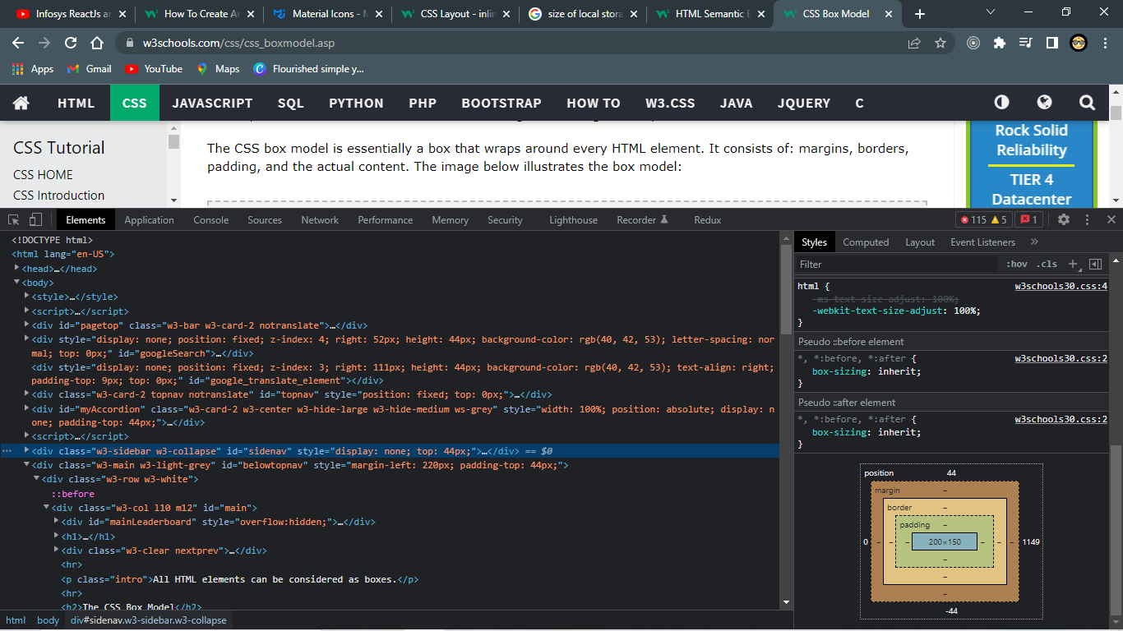

CSS Box Sizing
The CSS box-sizing property allows us to include the padding and border in an element's total width and height.

Without the CSS box-sizing Property
By default, the width and height of an element is calculated like this:
width + padding + border = actual width of an element
height + padding + border = actual height of an element
This means: When you set the width/height of an element, the element often appears bigger than you have set (because the element's border and padding are added to the element's specified width/height).
content-box is default border-box we can set

What is Specificity?
If there are two or more CSS rules that point to the same element, the selector with the highest specificity value will "win", and its style declaration will be applied to that HTML element.

Specificity Hierarchy
Every CSS selector has its place in the specificity hierarchy.
There are four categories which define the specificity level of a selector:
- Inline styles - Example: <h1 style="color: pink;">
- IDs - Example: #navbar
- Classes, pseudo-classes, attribute selectors - Example: .test, :hover, [href]
- Elements and pseudo-elements - Example: h1, :before
How to align element inside another element
there are many ways doing that flex box grids margin auto, and the absolute positioning,
with absolute positioning position absolute, top fifty percent left fifty percent and translate transform – 50% each,
How to make a triangle
We can create a div give it height and width of 0 and the give it three borders and the if we want top triangle for example we will make the borders of left and right transparent and will not specify the bottom border,
Pseudo elements
Pseudo elements are used to give the elements some extra effect, it allows extra markup without disturbing its environment we can do :: after an element and specify before or after where we want our pseudo element

Data Attributes
in html if we want to store data we can use data attributes
The data-* attribute is used to store custom data private to the page or application.
The stored (custom) data can then be used in the page's JavaScript to create a more engaging user experience (without any Ajax calls or server-side database queries).
The data-* attribute consist of two parts:
- The attribute name should not contain any uppercase letters, and must be at least one character long after the prefix "data-"
- The attribute value can be any string
Note: Custom attributes prefixed with "data-" will be completely ignored by the user agent.
<ul class="animal" >
<li data-animal-type="bird">Owl</li>
<li data-animal-type="fish">Salmon</li>
<li data-animal-type="spider">Tarantula</li>
</ul>
inside of css we can use
.animal li:hover::before {
content: attr(data-animal-type)
}
How to remove gap between inline-block elements?
Three methods, first negative margin, second inline the divs in HTML, third wrap them inside parent and give font size to zero,
How to manage z-index in an app?
In the theme or in the variables page we have predefined list where we set z-index and then we can use inside of the css.
How do you plan for accessibility in the css?
We need to prepare our website for different kind of disabilities visual auditory speech and other

Use case of !important?
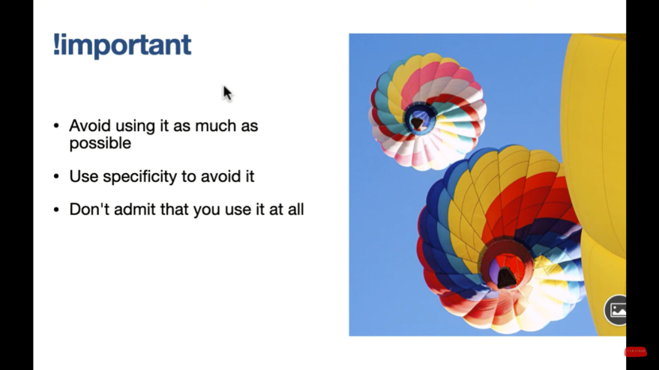
.el.el when we use this syntax?
to increase the specificity of the element whose class is el
Increase the specificity of class over id?
for the is we can use different syntax. [id=’id’]
#idname.classname
div#idname.classname

How do you do cross browser testing


HTML
HTML stands for Hyper text markup language, it is a language that tells the browser what to display in structure
What exactly is Doctype
<!Doctype html> this particular line tells browser that this piece of code is actually of type HTML5
Tags are used to markup the start and end of an Html element, and opening and closing tag along with content is the html element, some tags are self closing tag,

What do you know about metadata?
Metadata is the data about the data
meta information is set using meta tag for HTML document this information is not displayed anywhere or it is not visible to the user, metadata consists of the elements that are related to the page description keywords document related document, meta tags are found in the head section of the HTML, this information is used by the search engine to rank the web pages and let the users find the pages easily
What is the purpose of iframe in HTML
iframe in HTML tag specifies an inline frame, used to embed documents , video, interactive media within a page the source attribute is used to specify the url of the document that occupies the inline frame,
many add pages use iframe to display add in our web pages

What is the function of the pre tag in HTML
<pre></pre> tag specifies the pre formatted text it is to be presented exactly as written in the HTML file
the line breaks and the spaces are exactly the same, pre tag can be used to display organized computer code
Span tag
The span tag is used for grouping and apply styles to inline elements, it is similar to div which is a block level tag
HTML tag that not need closure
HTML tag that do not need closure are <img> <br> <hr> etc
Iframe tag
Iframe tag in html we can embed documents, videos, interactive medi a within a page the src attribute determines the url of the document that occupies the the inline frame
HTML 5
HTML 5 is the latest version of html
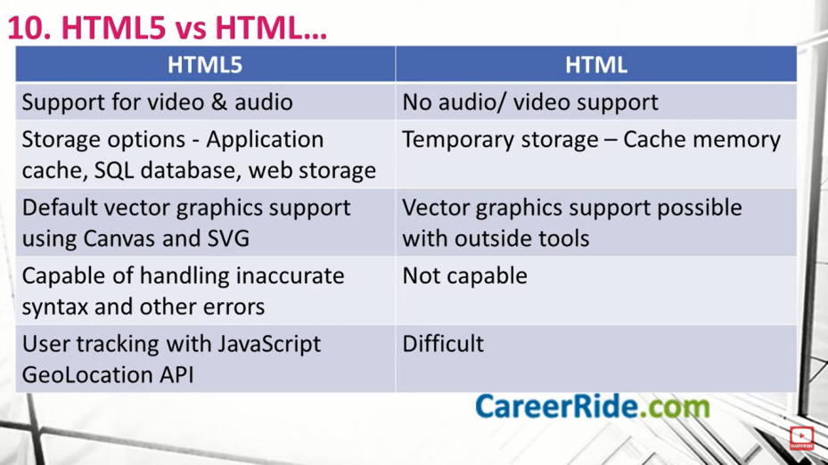
&#169 for copy right
Viewport
It is the visible area of the browser
<meta name=”viewport” content=”width=device-width”

Visibility hidden vs display none
visibility hidden simply hides the element but the space is allocated for it on the page, display none also hides the element but there will be no space allocated for it on the page, the page is appear as if the element is not present on it
Cell spacing vs cell padding
cell spacing is the gap between two cells of the same table
cell padding is the amount of space between the content inside the page and its borders
What is web workers?
Web workers is the JS which runs in the background without disturbing the performance of the page, it is used for computer heavy task
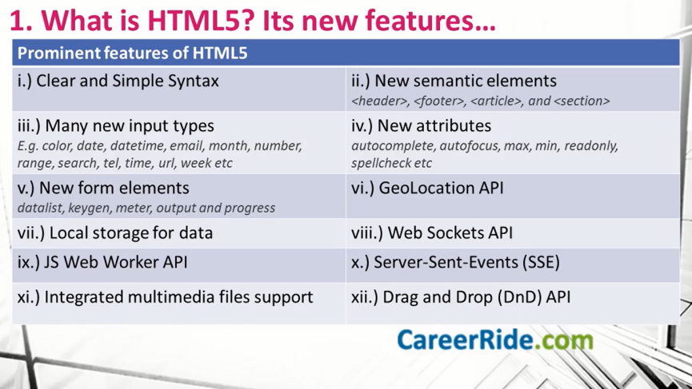
Semantic elements have been included <header> <footer> , <article>, and <section>
new input types such color, date many new attributes have also been included such as autocomplete max, min , autofocus , readonly , spell check, place holder, required, pattern, list , multiple ,
new form elements like datalist
The <datalist> tag specifies a list of pre-defined options for an <input> element.
The <datalist> tag is used to provide an "autocomplete" feature for <input> elements. Users will see a drop-down list of pre-defined options as they input data.
The <datalist> element's id attribute must be equal to the <input> element's list attribute (this binds them together).
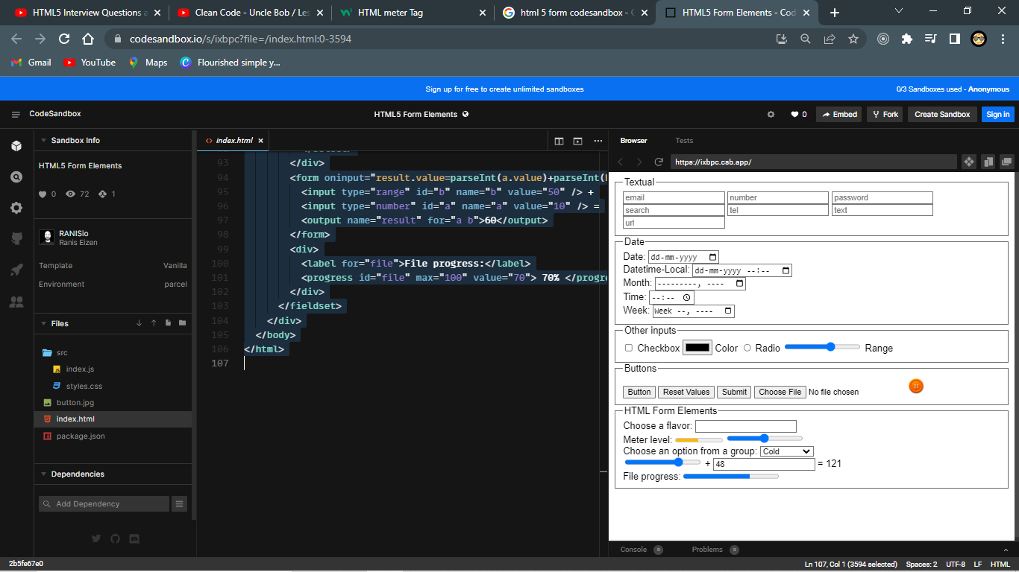
<!DOCTYPE html>
<html>
<head>
<title>Parcel Sandbox</title>
<meta charset="UTF-8" />
<link href="./src/styles.css" rel="stylesheet" type="text/css"></link>
</head>

<body>
<div>
<fieldset>
<legend>Textual</legend>
<input type="email" placeholder="email" />
<input type="number" placeholder="number" />
<input type="password" placeholder="password" />
<input type="search" placeholder="search" />
<input type="tel" placeholder="tel" />
<input type="text" placeholder="text" />
<input type="url" placeholder="url" />
</fieldset>
<fieldset>
<legend>Date</legend>
<label>Date: <input type="date" /></label> <br>
<label>Datetime-Local: <input type="datetime-local" /></label><br>
<label>Month: <input type="month" /></label><br>
<label>Time: <input type="time" /></label><br>
<label>Week: <input type="week" /></label>
</fieldset>
<fieldset>
<legend>Other inputs</legend>
<label><input type="checkbox" /> Checkbox</label>
<label><input type="color" /> Color</label>
<label><input type="radio" /> Radio</label>
<label><input type="range" /> Range</label>
</fieldset>
<fieldset>
<legend>Buttons</legend>
<input type="button" value="Button" />
<input type="reset" value="Reset Values" />
<input type="submit" />
<input type="file" />
<input type="image" src="./button.jpg" width="30" height="30" />
</fieldset>
<fieldset>
<legend>HTML Form Elements</legend>
<div>
<label for="ice-cream-choice">Choose a flavor:</label>
<input
list="ice-cream-flavors"
id="ice-cream-choice"
name="ice-cream-choice"
/>

<datalist id="ice-cream-flavors">
<option value="Chocolate"> </option>
<option value="Coconut"> </option>
<option value="Mint"> </option>
<option value="Strawberry"> </option>
<option value="Vanilla"> </option>
</datalist>
</div>
<div>
<form oninput="meter.value=parseInt(b.value)">
<label for="meter">Meter level:</label>
<meter
id="meter"
min="0"
max="100"
low="33"
high="66"
optimum="80"
value="50"
>
at 50/100
</meter>
<input type="range" id="b" name="b" value="50" />
</form>
</div>
<div>
<label for="select">Choose an option from a group:</label>
<select id="select">
<optgroup label="Tempreture">
<option>Cold</option>
<option>Warm</option>
<option>Hot</option>
</optgroup>
<optgroup label="Size">
<option>Small</option>
<option>Medium</option>
<option>Large</option>
</optgroup>
</select>
</div>
<form oninput="result.value=parseInt(a.value)+parseInt(b.value)">
<input type="range" id="b" name="b" value="50" /> +
<input type="number" id="a" name="a" value="10" /> =
<output name="result" for="a b">60</output>
</form>
<div>
<label for="file">File progress:</label>
<progress id="file" max="100" value="70"> 70% </progress>
</div>
</fieldset>
</div>
</body>
</html>

MULTIMEDIA
HTML gives us built in support for integrated multimedia files into the webpages with video and audio tag,
the new geo location api allows us to easily share location
video
<video width="320" height="240" controls>
<source src="movie.mp4" type="video/mp4">
<source src="movie.ogg" type="video/ogg">
<track src="fgsubtitles_en.vtt" kind="subtitles" srclang="en" label="English">
<track src="fgsubtitles_no.vtt" kind="subtitles" srclang="no" label="Norwegian">
Your browser does not support the video tag.
</video>
Audio
<audio controls>
<source src="horse.ogg" type="audio/ogg">
<source src="horse.mp3" type="audio/mpeg">
Your browser does not support the audio element.
</audio>
The <source> tag is used to specify multiple media resources for media elements, such as <video>, <audio>, and <picture>.
The <source> tag allows you to specify alternative video/audio/image files which the browser may choose from, based on browser support or viewport width. The browser will choose the first <source> it supports.
The <embed> tag defines a container for an external resource, such as a web page, a picture, a media player, or a plug-in application.
<embed type="text/html" src="snippet.html" width="500" height="200">
The <track> tag specifies text tracks for <audio> or <video> elements.This element is used to specify subtitles, caption files or other files containing text, that should be visible when the media is playing.
Tracks are formatted in WebVTT format (.vtt files).

Using HTML Geolocation
The getCurrentPosition() method is used to return the user's position.
The example below returns the latitude and longitude of the user's position:
<script>
var x = document.getElementById("demo");
function getLocation() {
if (navigator.geolocation) {
navigator.geolocation.getCurrentPosition(showPosition);
} else {
x.innerHTML = "Geolocation is not supported by this browser.";
}
}
function showPosition(position) {
x.innerHTML = "Latitude: " + position.coords.latitude +
"<br>Longitude: " + position.coords.longitude;
}
</script>

What is HTML Web Storage?
With web storage, web applications can store data locally within the user's browser.
Before HTML5, application data had to be stored in cookies, included in every server request. Web storage is more secure, and large amounts of data can be stored locally, without affecting website performance.
Unlike cookies, the storage limit is far larger (at least 5MB) and information is never transferred to the server.
Web storage is per origin (per domain and protocol). All pages, from one origin, can store and access the same data.

HTML Web Storage Objects
HTML web storage provides two objects for storing data on the client:
window.localStorage - stores data with no expiration date
window.sessionStorage - stores data for one session (data is lost when the browser tab is closed)
Before using web storage, check browser support for localStorage and sessionStorage:
if (typeof(Storage) !== "undefined") {
// Code for localStorage/sessionStorage.
} else {
// Sorry! No Web Storage support..
}

The WebSocket API (WebSockets)
The WebSocket API is an advanced technology that makes it possible to open a two-way interactive communication session between the user's browser and a server. With this API, you can send messages to a server and receive event-driven responses without having to call the server for a reply.

Server-Sent Events - One Way Messaging
A server-sent event is when a web page automatically gets updates from a server.
This was also possible before, but the web page would have to ask if any updates were available. With server-sent events, the updates come automatically.

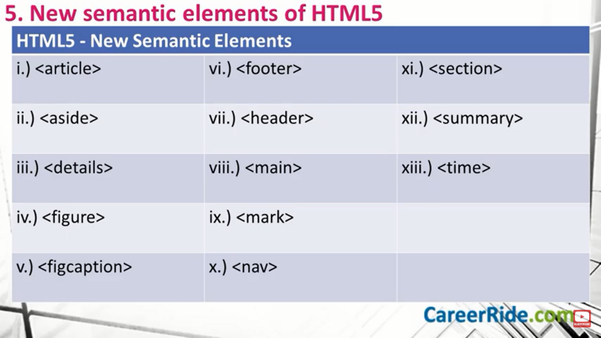
The <article> tag specifies independent, self-contained content.
An article should make sense on its own and it should be possible to distribute it independently from the rest of the site.
Potential sources for the <article> element:
- Forum post
- Blog post
- News story
Note: The <article> element does not render as anything special in a browser. However, you can use CSS to style the <article> element (see example below).
<article>
<h2>Google Chrome</h2>
<p>Google Chrome is a web browser developed by Google, released in 2008. Chrome is the world's most popular web browser today!</p>
</article>
The <aside> tag defines some content aside from the content it is placed in.
The aside content should be indirectly related to the surrounding content.
Tip: The <aside> content is often placed as a sidebar in a document.
Note: The <aside> element does not render as anything special in a browser. However, you can use CSS to style the <aside> element

The <details> tag specifies additional details that the user can open and close on demand.
The <details> tag is often used to create an interactive widget that the user can open and close. By default, the widget is closed. When open, it expands, and displays the content within. (accordion)
Any sort of content can be put inside the <details> tag.
Tip: The <summary> tag is used in conjuction with <details> to specify a visible heading for the details.
<details>
<summary>Epcot Center</summary>
<p>Epcot is a theme park at Walt Disney World Resort featuring exciting attractions, international pavilions, award-winning fireworks and seasonal special events.</p>
</details>

The <figure> tag specifies self-contained content, like illustrations, diagrams, photos, code listings, etc.
While the content of the <figure> element is related to the main flow, its position is independent of the main flow, and if removed it should not affect the flow of the document.
Tip: The <figcaption> element is used to add a caption for the <figure> element.
<figure>
<img src="pic_trulli.jpg" alt="Trulli" style="width:100%">
<figcaption>Fig.1 - Trulli, Puglia, Italy.</figcaption>
</figure>

<footer>
The <footer> tag defines a footer for a document or section.
A <footer> element typically contains:
- authorship information
- copyright information
- contact information
- sitemap
- back to top links
- related documents
You can have several <footer> elements in one document.

<header>
The <header> element represents a container for introductory content or a set of navigational links.
A <header> element typically contains:
- one or more heading elements (<h1> - <h6>)
- logo or icon
- authorship information
Note: You can have several <header> elements in one HTML document. However, <header> cannot be placed within a <footer>, <address> or another <header> element.

<main>
The <main> tag specifies the main content of a document.
The content inside the <main> element should be unique to the document. It should not contain any content that is repeated across documents such as sidebars, navigation links, copyright information, site logos, and search forms.
Note: There must not be more than one <main> element in a document. The <main> element must NOT be a descendant of an <article>, <aside>, <footer>, <header>, or <nav> element.

<mark>
The <mark> tag defines text that should be marked or highlighted.
<p>Do not forget to buy <mark>milk</mark> today.</p>
<nav>
The <nav> tag defines a set of navigation links.
Notice that NOT all links of a document should be inside a <nav> element. The <nav> element is intended only for major block of navigation links.
Browsers, such as screen readers for disabled users, can use this element to determine whether to omit the initial rendering of this content.

<section>
The <section> tag defines a section in a document.
<summary>
The <summary> tag defines a visible heading for the <details> element. The heading can be clicked to view/hide the details.
Note: The <summary> element should be the first child element of the <details> element.
<details>
<summary>Epcot Center</summary>
<p>Epcot is a theme park at Walt Disney World Resort featuring exciting attractions, international pavilions, award-winning fireworks and seasonal special events.</p>
</details>

<time>
The <time> tag defines a specific time (or datetime).
The datetime attribute of this element is used translate the time into a machine-readable format so that browsers can offer to add date reminders through the user's calendar, and search engines can produce smarter search results.
<p>Open from <time>10:00</time> to <time>21:00</time> every weekday.</p>
<p>I have a date on <time datetime="2008-02-14 20:00">Valentines day</time>.</p>

What is SVG?
- SVG stands for Scalable Vector Graphics
- SVG is used to define vector-based graphics for the Web
- SVG defines the graphics in XML format
- Every element and every attribute in SVG files can be animated
- SVG is a W3C recommendation
- SVG integrates with other W3C standards such as the DOM and XSL
The <svg> tag defines a container for SVG graphics.
SVG has several methods for drawing paths, boxes, circles, text, and graphic images.
<svg height="130" width="500">
<defs>
<linearGradient id="grad1" x1="0%" y1="0%" x2="100%" y2="0%">
<stop offset="0%" style="stop-color:rgb(255,255,0);stop-opacity:1" />
<stop offset="100%" style="stop-color:rgb(255,0,0);stop-opacity:1" />
</linearGradient>
</defs>
<ellipse cx="100" cy="70" rx="85" ry="55" fill="url(#grad1)" />
<text fill="#ffffff" font-size="45" font-family="Verdana" x="50" y="86">SVG</text>
</svg>

CanvasWhat is HTML Canvas?
The HTML <canvas> element is used to draw graphics, on the fly, via scripting (usually JavaScript).
The <canvas> element is only a container for graphics. You must use a script to actually draw the graphics.
Canvas has several methods for drawing paths, boxes, circles, text, and adding images.

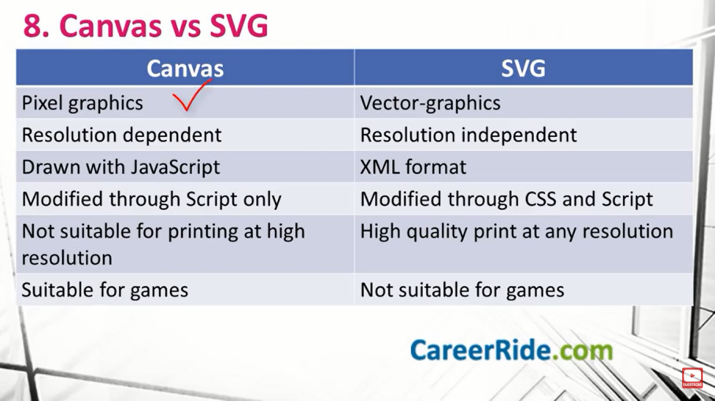

JavaScript
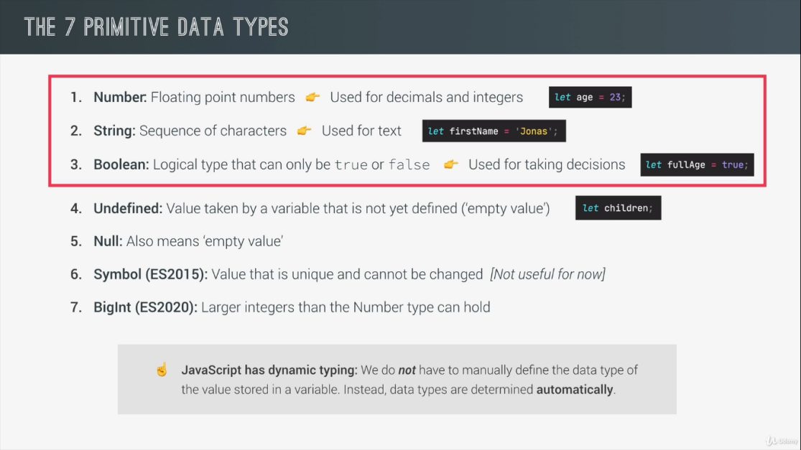
Type conversion is when we manually convert form one type to another
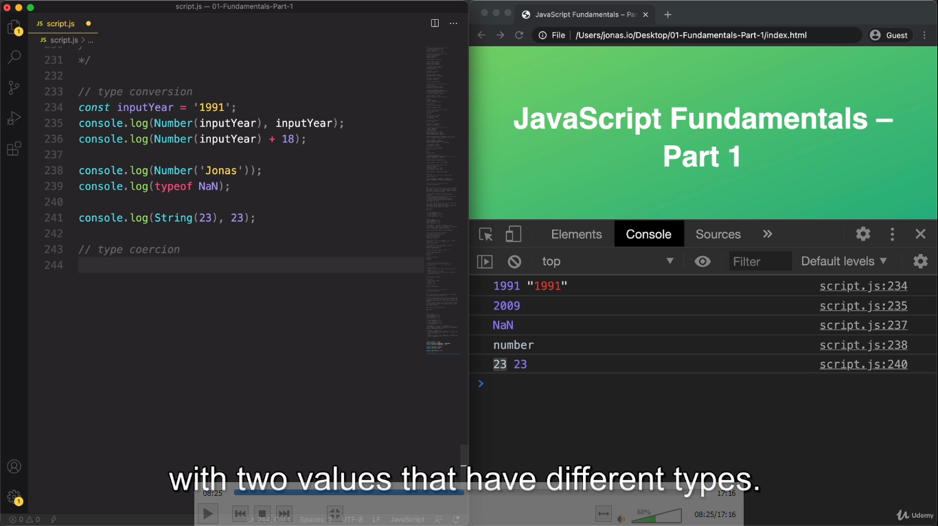
Type coercion is when javascript automatically converts types behind the scene for us. The plus operator triggers a coercion to strings so whenever there is operation between strings and the numbers the number will be converted to a string, same thing happens in the template literals it takes all the number values and convert them to string,
The minus operator converts the string to number same with the multiplier operator same for the dividing same with the comparison operators, only way it converts to string is the + operator.
Truthy and falsy values
Falsy values are the one that are not exactly false but will become false when we try to convert them into a Boolean, and in javascript there are only 5 falsy values, 0 , ‘ ‘ , undefined, null and NaN,
Everything else are so called falsy values, values that will be converted to true

Switch statement.
It’s another way of writing if else statement when we want to compare on value to multiple different options
The switch statement evaluates an expression, matching the expression's value to a case clause, and executes statements associated with that case, as well as statements in cases that follow the matching case.
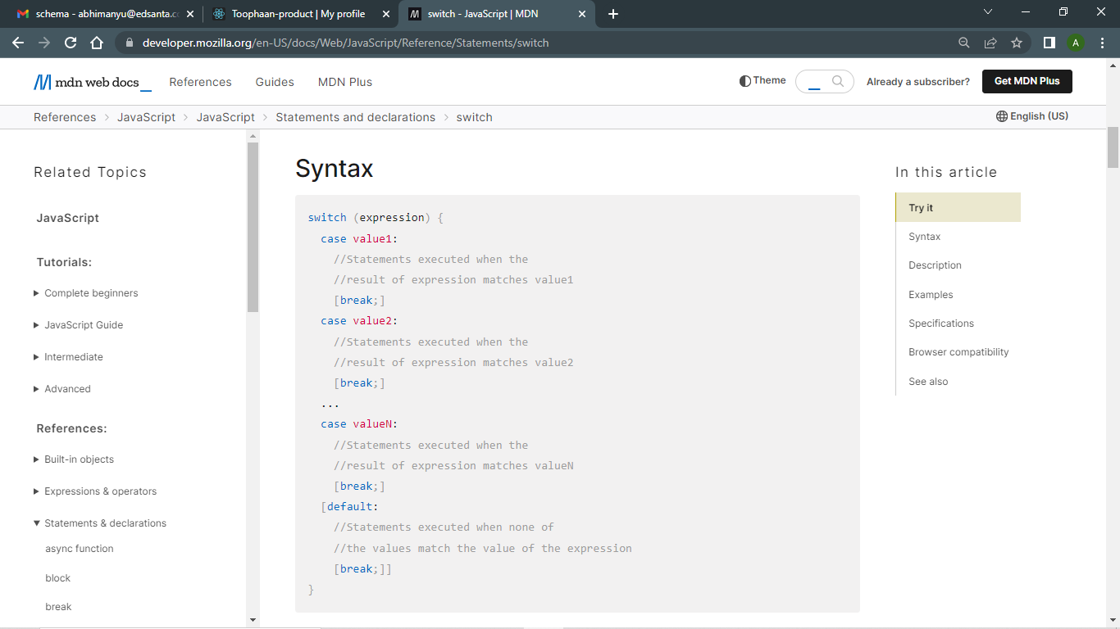
Statement vs expression
An expression is just a piece of code that produces a value eg ternary operator
A statement doesn’t produce a value eg if else statement

Strict mode
Strict mode is a special mode in javascript which helps us write more secure code, to activate strict mode we write ‘use strict’ at the beginning of the file, strict mode helps us to avoid bugs into our code, first it prevents us to do certain things and it creates visible errors for us in certain situations in which without strict mode javascript will simply fail silently without letting us know that we did a mistake

Function declaration vs function expression
In function declaration we simply use the function key word to declare a function a bit like we declare a variable
function func (){
console.log(‘I am a function declaration’)
return ‘function declaration’
}
We need to create a new variable to capture the value returned from the function call
In function expression we can directly store the function in a variable while declaring the function anonymously
const func= function () {
console.log(‘I am a function expression’)
return ‘function expression’
}

We call both functions in the same way

Arrow functions
Arrow function is a special way to write function expression without function keyword
const func= ()=> {
console.log(‘I am an arrow function’)
return ‘I am an arrow function’
}

.notaion vs bracket notation
we use objectName.keyName to access the property that we specify with the keyName
we can use the exact same thing using a bracket notation we use the keyName and then we use the brackets in a similar way in which we retrieve data from an array , inside of which we need to specify a string with a property name in our case keyName objectName[‘keyName’] . In the bracket notation we can put any expression that returns the string keyName so we don’t have to explicitly write the string here,
Object mehods
We can assign different methods to an object as a property and then use this key word to access or set the key value to the object,

For loop while loop
For loop takes in a counter a condition related to the counter and an incrementor for(let i = 1; i<= 10; i++){
console.log(‘running for loop’)
}
The code inside the curls will run until the condition is valid, For loop is used when we know how many times we have to run the computation,
While loop only takes in a condition and lets the code inside the curls run until the condition is true,
Let i=1
while(i<=10){
console.log(‘running for loop’)
i++
}
What is the DOM
DOM stands for document object model, It is a structural representation of the HTML documents, DOM allows javascript to access HTML elments and styles in order to manipulate them, we will be able to change texts, to change HTML attributes and also to change CSS styles from our javascript, DOM can be said to be a connection point between HTML document and javascript code,,
DOM is automatically created by the browser as soon as the HTML page loads and is stored in a tree structure. In this tree each HTML element is one object
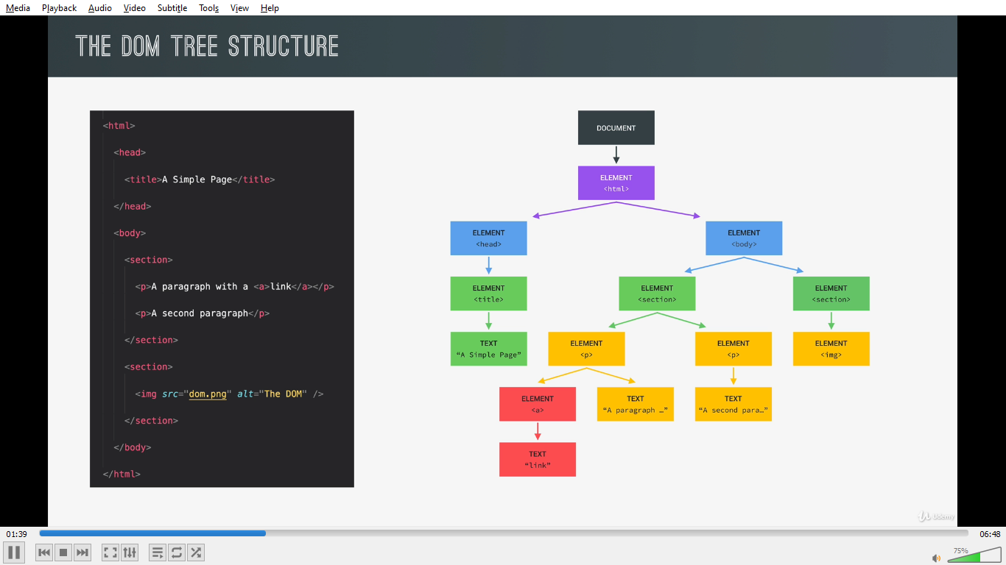
For each element in the HTML we have one element node in the DOM tree, and we can access and interact with each of the node using Javascript.
DOM always starts with the document object write at the very top and document is the special object that we access to in javascript and this object serves as the entry point to the DOM.
On the document object we have many available methods eg querySelector()
The first child object of the document is usually the HTML element because that is usually the root element in all the HTML documents, Next HTML has two child elements head and body which are siblings to each other,
Then as we keep going deeper into the nested HTML structure we keep adding more and more children to the DOM tree.
DOM tree actually has more than the element nodes it also has node for all the text itself comment and other stuff, as the rule is whatever is in the HTML document also needs to be in the DOM
DOM methods and property are not the part of javascript but part of web APIs

Event bubbling event capturing
If we click a button on an element we are also clicking the entire, hierarchy which will be in the direct parent child relationship, and all the click event from that child to the html in that hierarchal structure will be fired
By default the event bubble up it means from child the event propagates to the direct parent and then to its direct parent, the from clicked element to its direct parent then to its direct parent so on to the html,
If we use a false flag in our event listener then it will trickle down,

Javascript behind the scene
Javascript does not require us to manage the resources of our computer like memory, One of the powerful tool that takes memory management away from us garbage collection, which is an algorithm inside javascript engine which automatically removes the old unused object from the computer memory in order not to clog it up with unnecessary stuff.
Compilation vs Interpretation
In compilation all the code is converted into machine code at once and written to binary file that can be executed by a computer, we have two steps code conversion to machine code and then the execution, the execution can occur way after the compilation,
Interpretation has an interpreter that runs through source code and executes it line by line, here code is read and executed all at the same time
Javascript Engine
It is a program that executes JS code
It contains a callstack and a heap, the call stack is where our code is actually executed using something called execution context, the heap is an unstructured memory pool which stores all the objects that our application needs.
Modern JS engines use a mix between compilation an interpretation which is called just in time compilation, this approach compiles the entire code into machine code at once, then execute immediately,
We still have two steps of ahead of time compilation but there is no portable file to execute, execution happens immediately after compilation.
Execution context
Execution context is an environment where a piece of JS is executed, its like a box that contains all the necessary information for a code to be executed such as local variables and arguments passed into a function,
After the code has just finish compiling and the code is ready to be executed a global execution context is created for the top-level code, Top level code is the code that is not inside any function, at the beginning only the code that is outside any function is executed as functions should only be executed when they are called,
In any JS project however large is it there is only one global execution context, its always there as default context,
Once the top-level code finish to get executed functions finally start to execute as well,
For each and every function call a new execution context will be created containing all the information that is necessary to run exactly that function and same goes for methods as they are simply functions attached to an object,
All this execution context together makes the call stack, now when all the functions are done executing the engine will wait for the call back functions to arrive so then it can execute these, and it is the event loop that provides all these call backs.
Execution context is made up of a variable environment, in this environment all the function declarations are stored and there is also a special arguments object, this object has all the arguments passed into the function that the current execution context belongs to,
However, a function can also access the variable declared outside the function, this works because of something called the scope chain which consists of references to the variable that are declared outside of the function, finally each context also gets a special variable called this,
This keyword is generated in so called creation phase which happens write before execution, the execution context belonging to arrow function do not get their arguments keyword nor do they get this key word,
In fact, they can use the arguments object and this key word from their nearest parent
To keep track of the order in which the functions where called and to know where it is currently is in the execution context, the engines have the call stack, call stack is the place where the execution contexts get stack on top of each other in order to track where we are in the program execution,
The execution which is on the top of the stack is the one which is currently running, and when it is finished running it will be removed from the stack and execution will go back to the previous execution context, until it gets back to the global execution context and the program runs in this state forever if no further action is done by the user, and finally when the user closes the tab the global execution context is also popped of the call stack,

Scope Chain
Scoping means how our program variables are organized and accessed,
In JS we have lexical scoping where scoping is controlled by placement of functions and blocks in the code, for example a function which is written inside a function has the access to the variables of its parent function
Scope is an environment in which a certain variable is declared,
We might ask what’s the difference between scope and variable environment, the answer is that for the case of functions it is basically the same,
In JS we have global scope block scope and function scope, scope of a variable is the entire region where the variable could be accessed, block scope applies to the variable only declared with let and const, variables declared with var are block scope and can be accessed inside the function where the block is written,
Scope is not same as the scope of a variable, scope is environment where the variable is declared and scope of a variable is where the variable can be accessed,
Scope chain gets the access to the variables form the variable environment but it has nothing to do with in which order the functions will be called,
Hoisting in JS
Hoisting makes some type of variables accessible/usable in code before they are actually declared in code,
During the creation phase of execution context code is scanned for variable declarations and then for each variable that is found a new property is created in the variable environment object,
Hoisting works different for different variable declaration
Like for function declaration we can use the function declaration before they declared in code,
Variables declared with var are also hoisted but if we try to access variable declared with var we don’t get the declared value but we get undefined,
Let and const variables are not hoisted, technically they are hoisted but their value is set to uninitialized so there is not value to work at all these variables are placed in a temporal dead zone,
For function expression it depends if they were created var const or let,
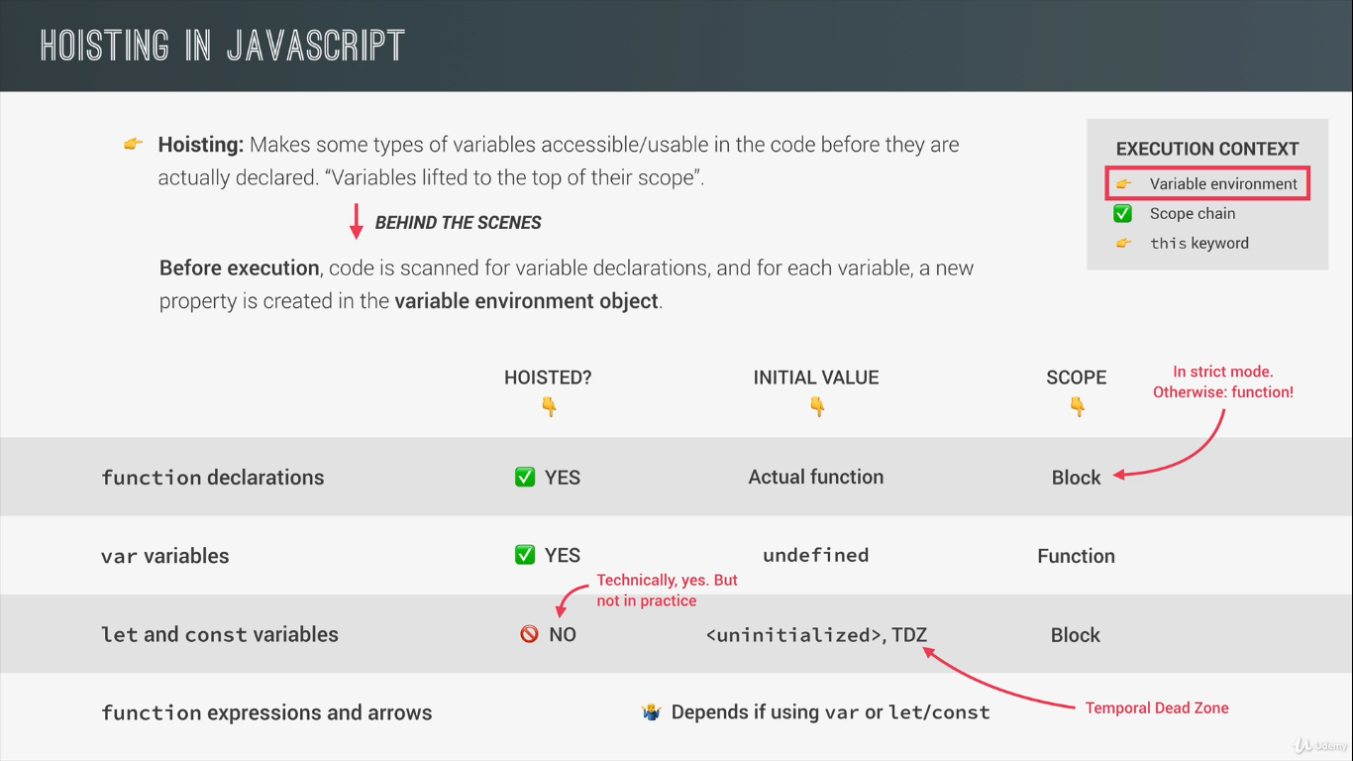

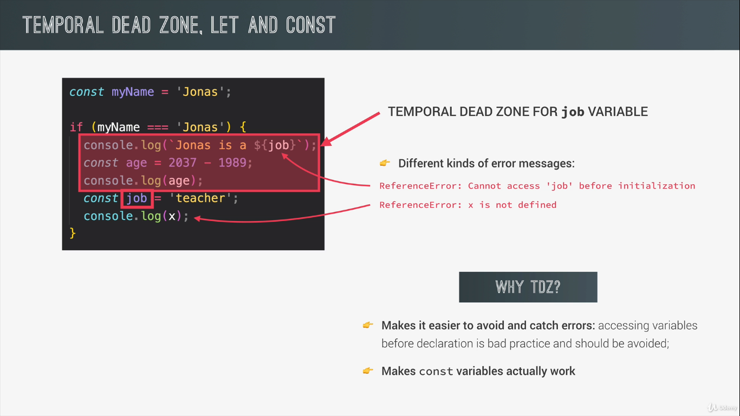
Hoisting exists in JS so that we can use function declaration before we declare them in the code,
This Keyword
This key word is a special variable that is created for each execution context, the value of this keyword is not static it depends on how the function is called,
There are 4 different ways in which the function can be called,
First is to call as a method as a function attached to an object, when it is called as a method this keyword will simply point to the object on which the method is called, or in other words it points to the object which is calling the method,
Another way we call function is by simply calling them as normal function so not as method so not attached to any object in this case this keyword will simply be undefined however that is only valid for strict mode
Next we have arrow function though arrow functions are not the way to call functions but they are extremely important in this regard because arrow function do not get their own this keyword, infact if we use the this key word in an arrow function it will be a this keyword of the surrounding function,
If function is called as an evenlistner then the this key word will always point towards the dom element that the handler function is attached to,
This will never point to the function in which we are using it and not its variable environment,

Primitive , objects and JS engine
When we are talking about memory and memory management it is usual to call primitives primitive type and objects reference type because of the different way objects are stored in the memory, as we know engine has two components call stack and heap where the objects are stored in the memory, All our objects the reference types get stored right in the memory heap, on the other hand primitives are stored in the call stack it means in the execution context in which they are declared,
To store a primitive type in the call stack the JS engine creates a unique identifier with the name of the variable we have assigned it to and then a piece of memory will be allocated with a certain address and finally the value will be stored in the memory at this specified address, identifier points to the address and not to the value itself, the value at the certain memory address is immutable it means it cannot change, so if we assign a new value to the variable while using let in the previous declaration the a new address is allocated, if we use const the JS will disallow for an new memory address to be allocated to the variable and the value will remain same

While when a new object is created it is stored in the heap and as before there is a memory address and then the value itself, in case of the reference value the me identifier does not point to the memory address, in fact it points to a new piece of memory that is created in stack and then this new piece of memory will have value of memory address of the heap in the call stack, the piece of memory in the call stack has a reference in the heap which holds our object and that’s why we call objects reference types,
Even if we declare the object with const the memory address of the heap will remain same event if we change the property of the object stored in the heap,

Destructuring
const arr=[1,2,3]
const [x,y,z] = arr
When JS sees brackets at the left of the assignment operator it knows it has to destructure, even though we do destructuring the original array does not get effected,
To destructure objects we need to use the exact property names to extract variables from the object, In objects the order of element does not matter so we do not need to manually skip the elements like in array,
const user = { name: ‘user1’, email: ‘user@gmail.com’, phno: 7635047441 }
if we want name and phno only we can destructure like const {name, phno } = user
now suppose we want the phno to be called as tel so we can destructure like const {phno: tel} = user
if we declare the objects using let
let obj = {a: 1, b:2}
we can reassign a and b like this
({ a, b }) = obj
We use parenthesis as JS may register curls as code block and give unexpected token error
Spread operator
Spread operator is a new way of unpacking array and the objects.
const arr1 = [1,2,3]
const arr2 = [4,5,6]
if we want to merge above array in two array, we can do like, const arr3 = […arr1, …arr2]
working with spread operator could look similar to destructuring because it also help us get element out of the array, the big difference is the that spread operator takes out all the elements from the array and it also doesn’t create new variables and as a consequence we would only write them with values separated with comma,

other use case instead of merge could be to create shallow copies of the array like
const arr3copy = […arr3]
spread operator works on the iterables except the array , strings, maps , sets
.
Rest pattern
Rest pattern has the exact syntax as the spread operator but it actually does the opposite, In means rest pattern instead of expanding and array it will collect multiple elements and condense it into the array,
If we use on the right side of the assignment operator that is spread, however we can use it on the left side of the assignment operator together with destructuring,
const arr = [1,2,3 , …[4,5,6]]
const [a,b,…others] = [1,2,3,4,5,6]
a and b will take 1and 2 respectively while others will become a new array [3,4,5,6]
rest patters basically collects the elements that are unused in destructuring assignment,
rest syntax collects all the elements after the last variable, so it does not include and skipped element for that reason the rest pattern always be the last in the destructuring assignment, otherwise how will JS know until when it should collect the rest of the array,
rest pattern also works with the objects

&& || operator
|| operator will return the first truthy value of all the operands or simply the last value if all of them are falsy,
&& operator will return the first falsy value or the last value if all of them are truthy,
We can use || operator to set default values
We can use && operator to execute code in the second operand if the first one is true,
Nullish coalescing operator ?? for this 0 and ‘ ’ empty string are not falsy value,
for of loop
This loop will automatically loop over the entire array and in each iteration it will give access to the current iteration element
for (const of item) {
console.log(item)
}

Object.keys and Object.values
Object.keys wil give the array of the keys and Object.values will give the array of the values,
Object.entries(obj) will give the array of keys and values
arr.entries gives the array of object of index and the values,
String Methods
string.length() for the length
string.indexOf(‘h’) at what position h is located in the string
string.lastIndexOf(‘r’)
if the r is not found this will return -1
string.slice(a,b) a-1th and bth value will not be included in the string the length of the extracted string will be b-a where a and b are integers
string.trim to remove the white space
string.replace(‘a’, ‘b’) a replaced to b
string.includes(‘str’) if ‘str’ is a part of the string
string.startsWith (‘str’) if ‘str’ is at the start of the string
string.endsWith (‘str’) if ‘str’ is at the end of the string
string.split(‘a’) split method is used to divide the string in to various parts where a is part of the string and then store the results in the array array.join(‘ ‘) converts the array of string into a string with devider string, here we have empty string
string.padStart(10, ‘+’) applying padding of + 10 times infront of the string similarly we have padEnd

First class functions
Javascript treats funcitons as first-class citizens, it means functions are simply values, because functions are another JS object and since objects are values functions are values too, we can store them in variables and as object property, we can also pass functions as arguments to other functions, we can also return a function from other function,
As functions are also objects we also have methods which we can call on functions eg .bind(),
HOF A function that receives a function as argument and return other function, and the function that is passed is called call back function that is because it will be called later by the HOF not by us,
First class functions are just a feature that a programming language either has or does not have, all it means that all functions are values, HOFs are possible because the language supports first class functions
Call back functions help us to split our code in more reusable and interconnected part, and call back functions allow us to create abstractions, the higher order function does not care about how the functionality is implemented in the callback function, for example the add event listener function will have no idea what to do whenever the click event happens it just calls a call back function and it does the corresponding task,

Funcion methods
function.call allows us to manually or explicitly set the this keyword of any function that we want to call,
function.call( obj, a, b ) where obj is the object to which we want to set the this keyword and a and b are the arguments,
function.apply this method does basically the same only difference is that the apply does not receive the list of arguments after the referred object but instead it will take an array of list of arguments,
function.apply(obj, [a,b])
function.bind this method also allows us to manually set the this keyword for any function call the difference is that the bind does not immediately does not call the function instead it returns a new function where the this key word is bound
const funcBind = function.bind(obj) this will always call the function for the obj

Immediately invoked function
Some times in javascript we need a function that is only executed once, we write the function without assigning it to any variable and wrapping it in parenthesis and then calling them like
(function(){ console.log(‘Immediately invoked function’)})()

Closure
It is not a feature that we explicitly use, it means we don’t create closures manually, A closure simply happens automatically in certain situation we just need to recognise those situation,
In javascript a function has access to all the variables declared in its scope chain, it means its parent and above, now if the function is not a pure function it means it uses a variable that is neither passed into it as arguments nor declared inside of it then during the execution of that function all such variables get stored as key value pair in the scope of the function on the closure object,
Even if it at the time of the execution of this function the variable environment is no more available it still is present in the closure object as a key value pair,

Array methods
array.slice(a,b) slices the array in part without changing the original array and returns an array with elements from array[a] to array[b-1] array.slice(a, -b) will return array with elements from array[a] to array[array.length - b+1], array.slice(-b) will return last b elements of the array,
array.splice The splice() method changes the contents of an array by removing or replacing existing elements and/or adding new elements in place
splice(start)
splice(start, deleteCount)
splice(start, deleteCount, item1)
splice(start, deleteCount, item1, item2, itemN)

start is the index at which we start changing the array, if the delete count is 0 no elements are removed, item1, will be added at the index start
array.reverse to reverse the elements of the array
array1.concat(array2) to merge two arrays,
array.join(‘-‘) to join the array to a string with – in between the elements
forEach Method
forEach is a higher order function, which requires a callback function, this callback function will be executed at each iteration of the array with access to the item index and the entire array as first second and the third parameter, if we want to loop through all the elements of an array and don’t need a returned array, use the forEach method, for each method creates side effects
numbers.forEach(number => console.log(number));

map method
map method gives use a brand new array and this new will contain in each position the result of applying a call back function to original array elements.
let numberArray = [1, 2, 3, 4, 5];
//output the square of each number
let returnValue = numberArray.map((num) => num * num)

filter method
filter method is used to filter for elements that satisfy a certain condition, to specify such condition we use a call back function, for which only the values that pass the condition will make into the new array, the call back function gets its argument as forEach method,
const words = ['spray', 'limit', 'elite', 'exuberant', 'destruction', 'present'];
const result = words.filter(word => word.length > 6);
console.log(result);

reduce method
We use the reduce method to reduce all the elements in an array to a new value
The reduce() method executes a user-supplied "reducer" callback function on each element of the array, in order, passing in the return value from the calculation on the preceding element. The final result of running the reducer across all elements of the array is a single value.
The first parameter is something called the accumulator , this accumulator keeps accumulating the value that we ultimately want to return
const array = [15, 16, 17, 18, 19];
function reducer(previous, current, index, array) {
const returns = previous + current;
console.log(`previous: ${previous}, current: ${current}, index: ${index}, returns: ${returns}`);
return returns;
}
array.reduce(reducer);
find method
we can use find method to retrieve on element of an array based on a condition, it also accepts a call back function, the call back function should return a boolean just like filter method, but unlike filter method it will not return a new array it will only return the first element in the array that satisfy this condition
const inventory = [
{name: 'apples', quantity: 2},
{name: 'bananas', quantity: 0},
{name: 'cherries', quantity: 5}
];

const result = inventory.find( ({ name }) => name === 'cherries' );

console.log(result) // { name: 'cherries', quantity: 5 }

Timers
We have two timers in javascript setTimeOut and setInterval()
setTimeOur timer runs just once after a defined time while setInterval timer keeps running until we stop it
we can use setTimeOut to execute code in future
setTimeout(() => {
console.log("Delayed for 1 second.");
}, 1000)
setInterval(function () {element.innerHTML += "Hello"}, 1000);

DOM working
We know that dom is basically the interface between our JS code and browser
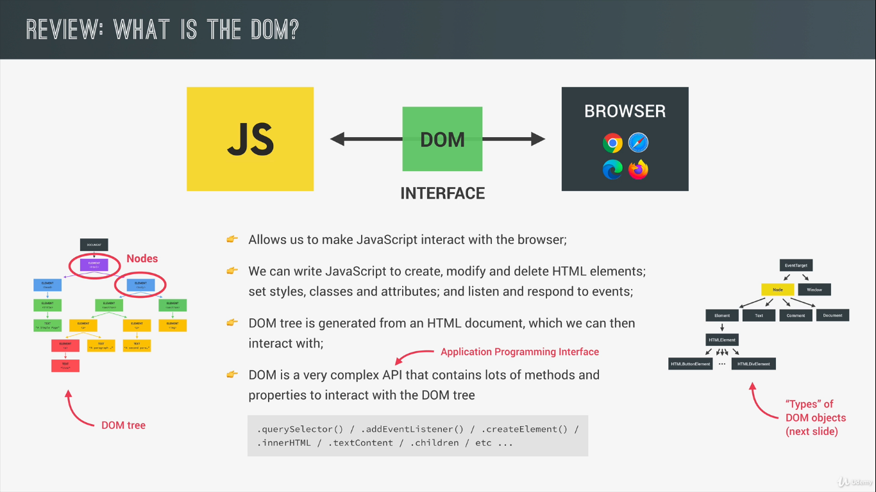

DOM API behind the scene
Every single element inside the DOM tree is of the type node, and each node in JS is represented as an object, this object gets access to special node methods and properties such as .textContent, .childNode,. parentNode, .cloneNode and the others, every node type has some of child type, and these are the element type, text type, comment type , and document type,, for example whenever there is text inside and element it gets is own node and that node will be of the type text, and same happens for the HTML comments, for element type we have many useful properties such as innerHtml , classlist, children, parentElement and methods like append, remove, insertAdjecentHtml, querySelector, closets , matches, scrollIntroView, setAttribute etc,
Each element has an html element child type and and that HTML element has internally onechild type for each HTML element that exist in HTML we have special type for buttons images links and so on
Each of these HTML elements can have unique properties for example an image has source attribute in HTML which no other element has like anchor element has href attribute, DOM has way of storing these attributes therefore different type of HTML elements has been created in DOM API
Inheritance makes all of this work, inheritance gives access to the child types all the properties of their parent type

Event
An event is a signal generated by a DOM node, A signal mean that something has happened ex click event and we can listen to these events in our code using eventListeners

Event Delegation
It is based on event bubbling Capturing and bubbling allow us to implement one of the most powerful event handling patterns called event delegation.
The idea is that if we have a lot of elements handled in a similar way, then instead of assigning a handler to each of them – we put a single handler on their common ancestor.
In the handler we get event.target to see where the event actually happened and handle it.
DOM Traversing
DOM traversing is basically walking through the dom which means we can select an element based on another element, we need to some time select an element relative to another element for example a direct child or a direct parent element as sometimes we don’t even know the structure of the DOM at runtime, in all these cases we need DOM traversing
We can use queryselector on element to and then apply the selector class to select the child of the element
Similarly closest can be use to traseverse throgh the parent
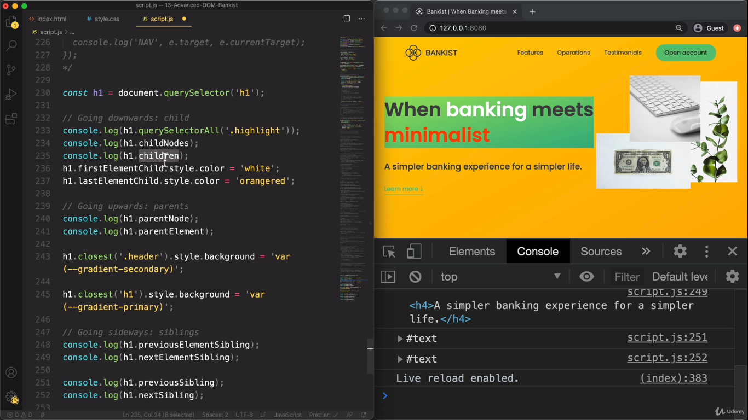

Object oriented programming
Object oriented programming is a programming paradigm based on the concept of objects, paradigm means style in which we organize our code.
We use objects to model real world like user or to-do item or abstract features such as html element,
Objects contain data as properties and methods, by using objects we pack data and corresponding behaviour in one block,

Class and instance
In OOP we need a way to generate new objects from our code to do that in traditional OOP we use something called classes,
Class is blue print which can be used to create new objects based on the class, we call all objects created through a class instances of that class, an instance is an real object that we can use in our code which was created from a class and the class itself is not an object, we use this class to created as many instances as we need in our application, and all of this instances can have different data in them but they all share the same functionality,
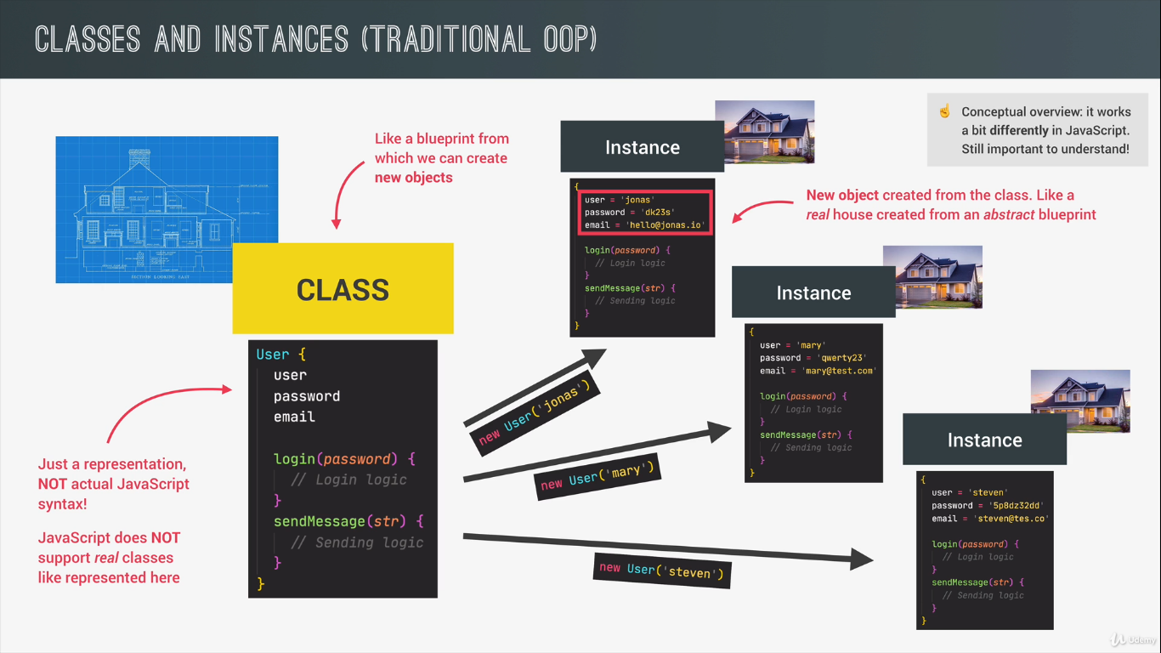
4 fundamental principles of object-oriented programming,
Abstraction
Encapsulation
Inheritance
Polymorphism
The above techniques can be used out side of the OOP but they are especially relevant in this concept
Abstraction Encapsulation
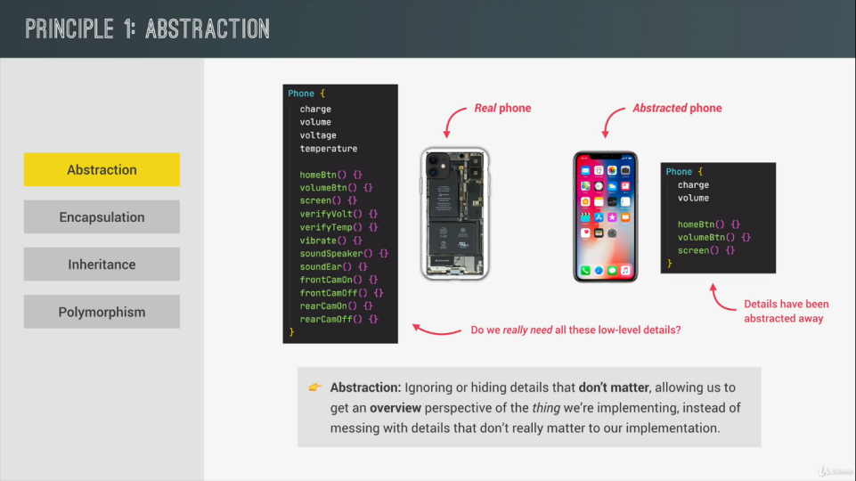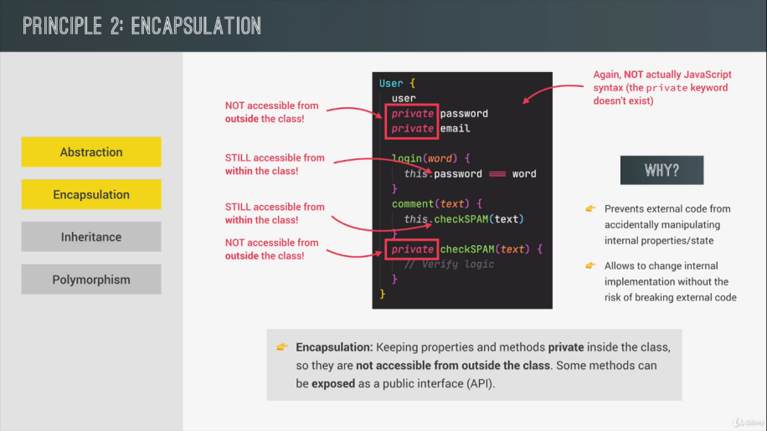

Inhertance Polymorphism
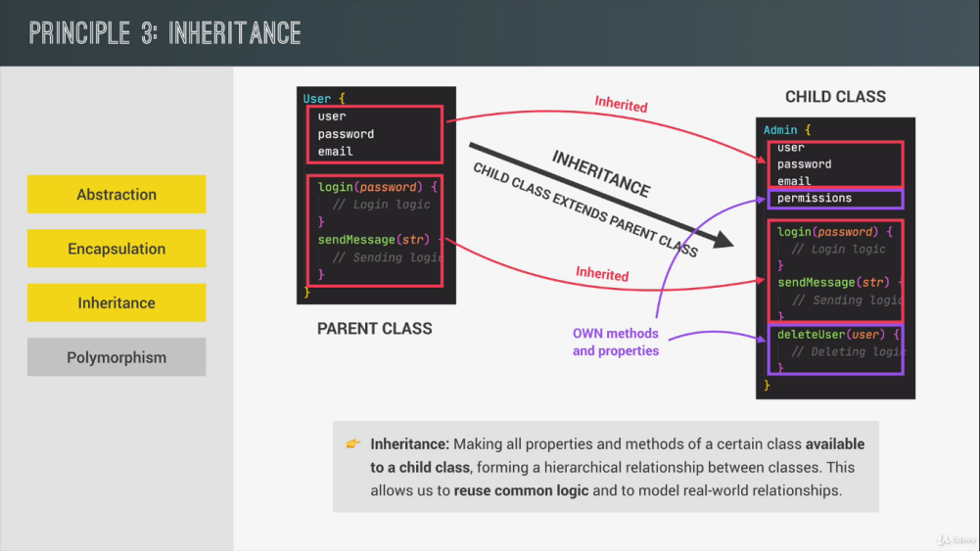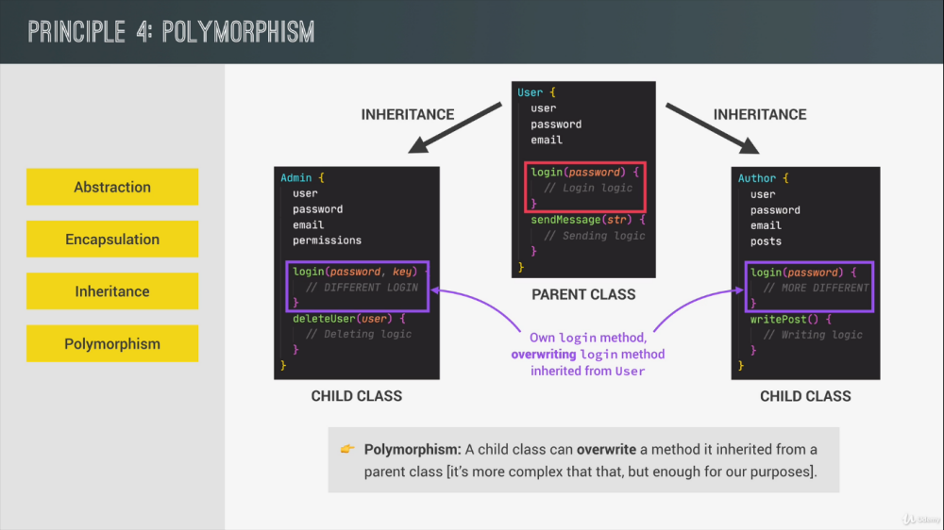
OOP in JS
We have similar class instance model in JS but different from other languages, In JS we have prototypes,
we say that each object has prototype, Prototype object contains methods and properties that all the objects that are linked to that prototype can access and use and this behaviour is called prototypal inheritance,
Objects inherit the properties and methods from their prototype that’s why this mechanism is called prototypal inheritance,
In other language we have one class inheriting from another class but in this case its basically an instance inheriting from a class,
Objects delegate methods to the linked prototype object , we also called the prototypal inheritance, technically objects delegate the behaviour to the prototype on the other hand in classical OOP the behaviour or the methods are copied from the class to the objects
For example, each time we are able to implement the map method on the array because to prototypal inheritance.
Array.prototype is the prototype for all the array that we create in JS
Our array inherits the map method or we can say array delegates the map method to is prototype.
To Implement OOP in JS we have 3 different ways of doing all this, the constructor technique, ES6 classes and Object.create function,
Constructor functions are a way of creating object programmatically using a function which will also set the new object prototype and this is how the built in array methods are implemented, this is how OOP has been done in JS
ES6 release introduced classes in JS however these are not the actual classes they are just synthetic sugar over construction function
Object.create function can also be used to link an object to its prototype
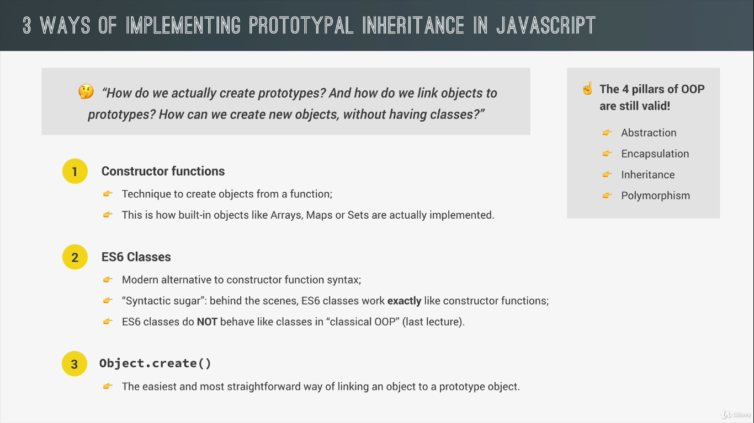

Constructor function
We can use constructor functions to build an object using function, the difference between a regular function and constructor function is that we call constructor function with a new operator,
Only function declaration and the function expression can be used as constructor function.
const Person = function(firstName, lastName) {
this.firstName = firstName;
this.lastName = lastName;
}
and to call the constructor function
new Person(‘Kumar’, ‘Abhimanyu’)
When we call a function with a new operator steps happen
1 A new empty object is created
2 the function is called and in this function call the this keyword is set to this newly created empty object, In execution context of Person the this keyword will point to newly created object
3 this newly created object is linked to the newly created prototype
4 the object that is created in the beginning is automatically returned from the constructor function
Therefore to build the object that we require we can use the this key word and build it as we like
And then we can use this constructor function to create any number of objects
const Abhimanyu = new Person(‘Abhimanyu’, ‘Kumar)

Prototypes
Each function in JS automatically has a property called prototype and that includes constructor function.
Every object that is created by the constructor function has access to the methods and the properties we describe in its prototype property,
Person.prototype
Inheritance in JS is done by using prototype object, in JS inheritance is object based and not class based
The child.prototype will points towards the parent object, every thing that belongs to the parent will be accessible by the parent but child can also have some extra properties and methods and child can override which is something in the parent
Every object by default in JS has a prototype object
prototype object creates a linklist it means child object will have a linklist object of the parent
and that is why it is termed as prototype chaining, it means if we want to access a property or a method in child it will first try to search that property or the method in the current object if it does not get it will go inside the prototype and see if it is present there it will go to the parent object and see if it is present there if it is not available there it will look in the parents prototype and so on.

ES6 classes
It’s a new method to construct classes in javascript, they still implement the prototypal inheritance behind the scene but with different syntax, they are just syntactic and are not same as classes in other language.
they can be declared as function declaration or function expression using the class key word
const Person = class(){}
class Person() {
constructor(firstName, lastName){
}
}
const manyu = new Person(‘Kumar’, ‘Abhimanyu’)
Inside the class first thing that we need to do is to add constructor method and this constructor works in similar way as constructor function and just like constructor function we pass here the properties and methods we want the object to have
Act of creating object also works in exact same as before using the new operator,
and to define the object in the constructor we do this. to the arguments.
And the methods can be included out side of the constructor and all of them will be available on the prototype of the object and not on the object themselves, with this syntax we don’t have to mess with the prototype property as we write the methods in the class they are automatically available on the prototype property of the class and thus to all the children created with new keyword

Setters and Getters
Every object in JS has getters and setters property and we call these assessor properties and while normal properties are called data properties, getters and setters are functions that get or set a value
We start by writing a normal method lets say to get deposits of an account and then to transform it into getter we prepend get
get getDeposits(){
return this.deposits
}
And then to use the getter we simply write
account.getDeposits we don’t call the method we write it if it was just a property this can be very useful if we want to read something as a property but still want to do some computation before
We do the same with setter set but any setter methods needs to have atleast one parameter
set setDeposits(amount){
this.deposits = {…deposits, amount}
}
And we can use like account.setDeposits = 50
Classes also have getters and setters and they do indead work in the exact same way

Static methods
These methods are not available on the prototype of the object and are attached to the constructor like Array.from is not available on all arrays but The Array.from() static method creates a new, shallow-copied Array instance from an array-like or iterable object.
to write we can do like
Const account.activate = fn (){ console.log(‘activate’)}}
In es6 we can just add use static keyword as we use get key word

Object.create
We can use object.create to manually set the prototype of an object to any other object that we want.
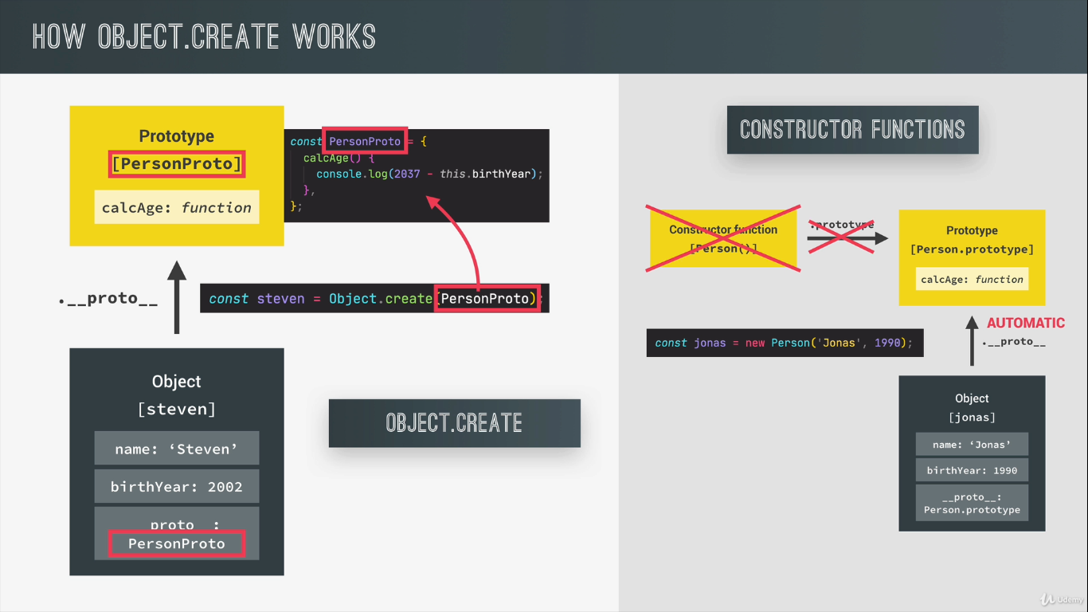
Prototypal inheritance constructor function
__proto__ is the actual object that is used in the lookup chain to resolve methods, etc.
is an internal property of an object, pointing to its prototype.
prototype is the object that is used to build __proto__ when you create an object with new: it’s a property of a Function object. It is the prototype of objects constructed by that function.
function Point(x, y) {
this.x = x;
this.y = y;
}

var myPoint = new Point();

// the following are all true
myPoint.__proto__ == Point.prototype
myPoint.__proto__.__proto__ == Object.prototype
myPoint instanceof Point;
myPoint instance of Object;

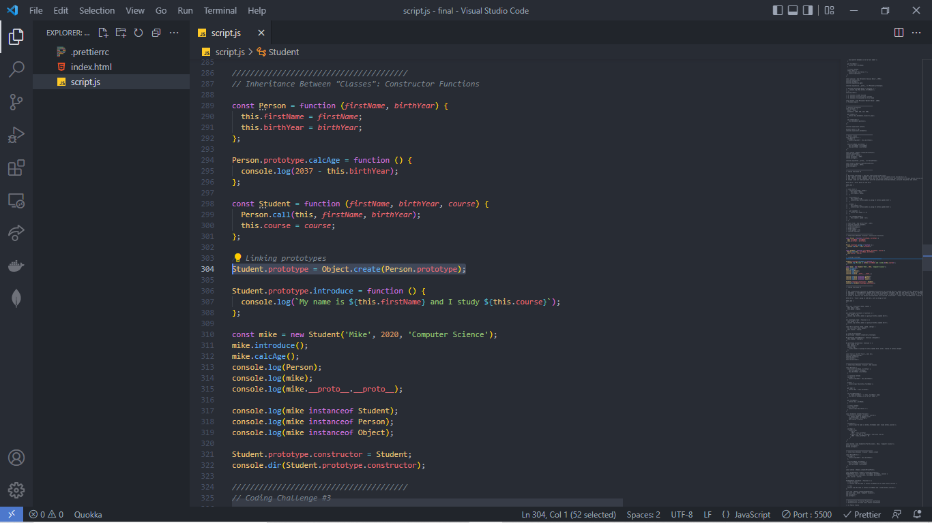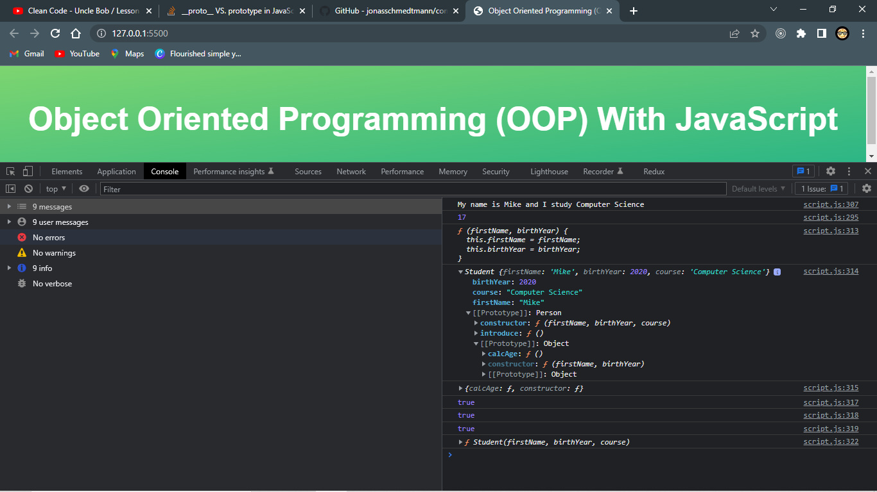
At first we have a constructor function named Person which takes firstName and birthYear as argument to create an object,
We define the content of the object as this.firstName = firstName and this.birthYear = birthYear where this.firstName and this.birthYear will generate fields on the objects created from this constructor function with new keyword taking argument as firstName and lastName,
We create a method called calcAge on the prototype property of the Person’s constructor
And then we have another constructor function named Student which takes in the same argument as the Person and also the course, To define the properties we use the Person constructor function for firstName and the birthyear and for the course we write this.course = course.
Then to make the Student constructor child of the Person constructor we use Object.create and make the prototype of Student equal to Person and thus we can inherit all the methods associated with Person constructor inside of Student constructor on Person prototype
We add a method to Student’s prototype property name introduce
Finally, we create the mike object from student constructor passing firstName, birthYear and course.
We can see in the console of line 314 that mike is an object created from Student constructor on it’s prototype we have we have Person constructor and onto Person’s prototype we have calcAge method linked to the Mike object with protype chaining,
The constructor of student.prototype is Person here and the reason for that we set the prototype property of the student using Object.create this makes it so that the constructor of student.prototype is still student,
as we can see the console of both 317 and 318 are true
To fix this we can set Student.prototype.constructor = Student.

Prototypal inheritance ES6 classes
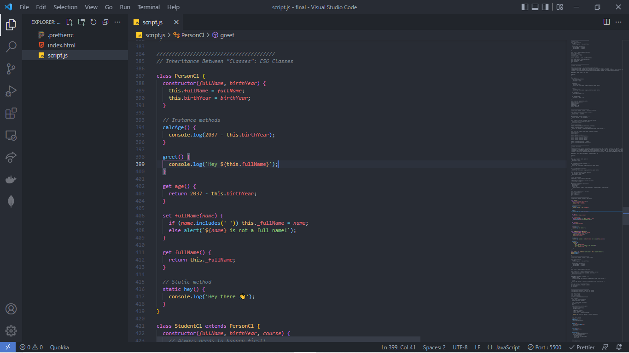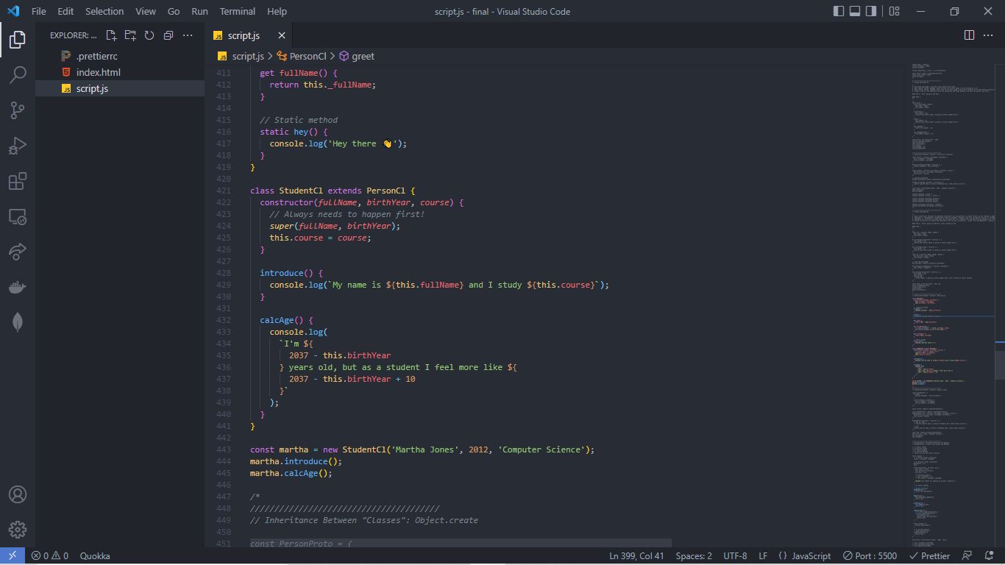
To implement inheritance between ES6 classes we only need two ingredients we need the extend keyword and we need the super function, to make this Student class from the person class
class StudentCl extends PersonCl {}
extends keyword links the prototype behind the scene without us event to think about it,
then we still need the constructor and this will just like before receive the same arguments as the parent class and some additional ones like the course here
we don’t need to manually call PersonCl like in the constructor approach what we don instead to call the super() which is basically the constructor function of the parent class, the idea is similar but here it is abstracted, inside of super we pass the arguments of the constructor class, super() call always needs to happen first because this call to the super function is responsible for creating the this keyword in this subclass
therefore we must call super constructor in derived class before accessing 'this' or returning from derived constructor.
If we didn’t want to access this we would not need the constructor at all in that case the super function will automatically be called with all the arguments.
And every thing we can just implement like before
console.log(marhta) gets us
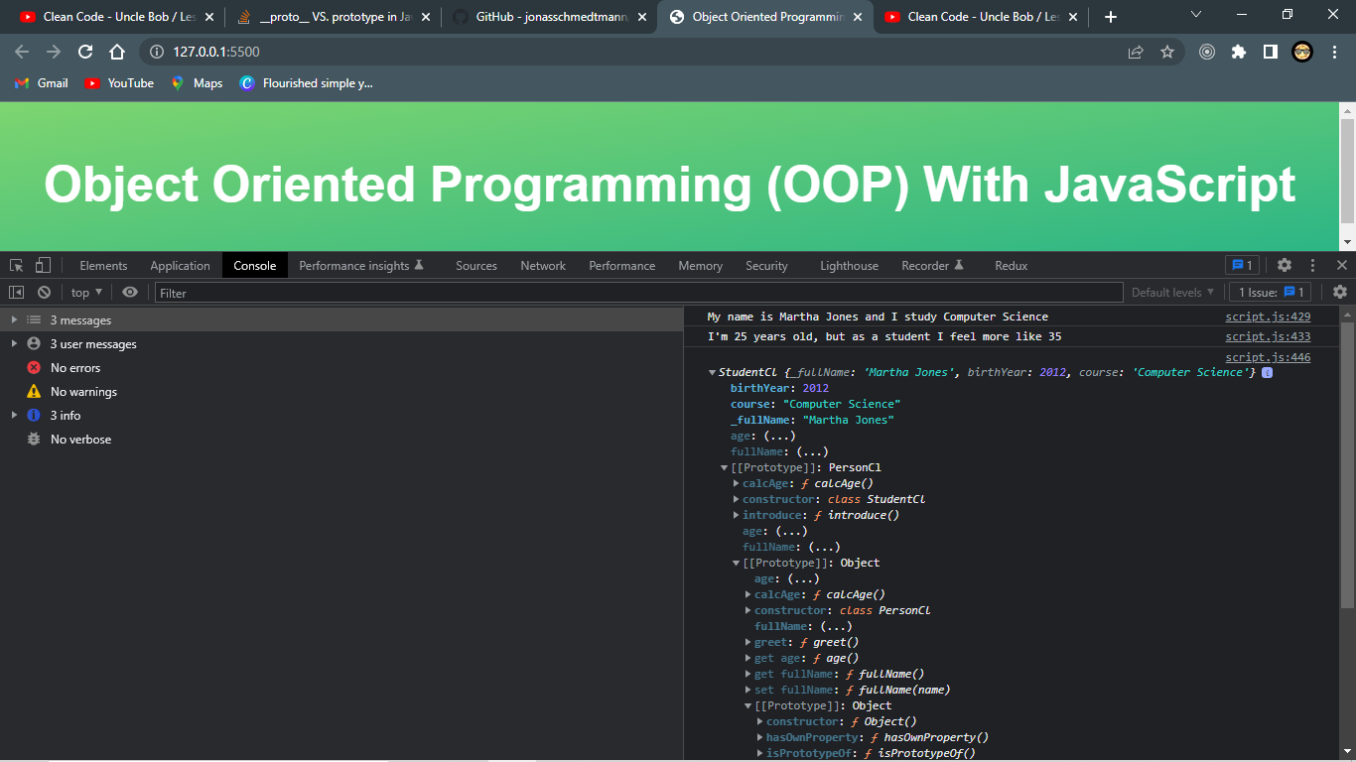
Prototypal inheritance Object.create
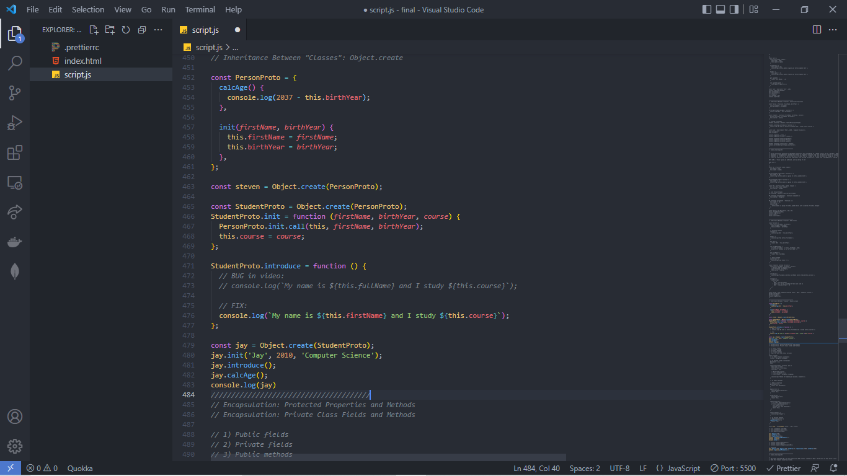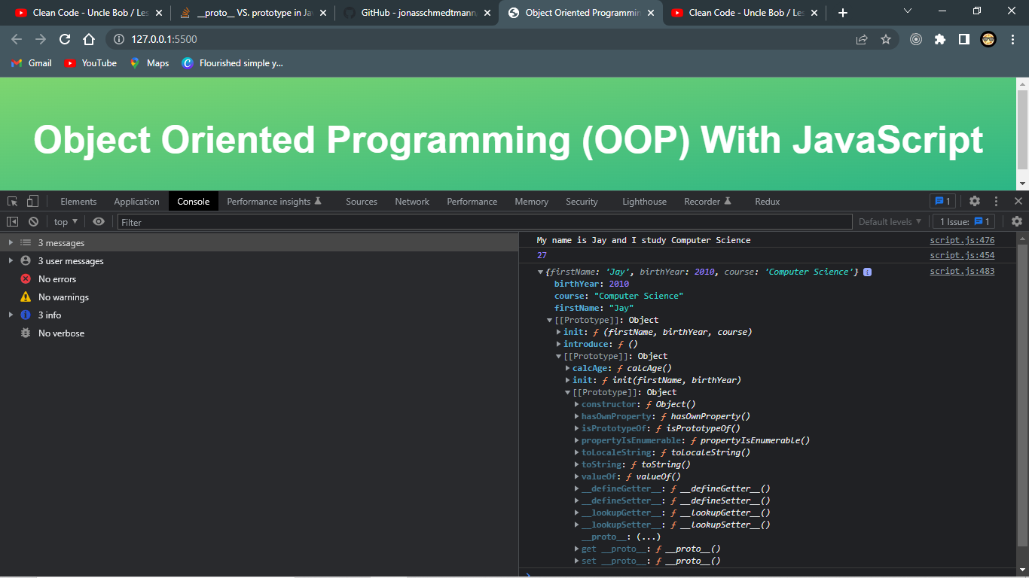
The PersonProto serves as an object to create steven object using Object.create
if we want to include another prototype called Student in the middle of the chain, We will make Student inherit directly from Person,
const StudentProto = Object.create(PersonProto);

We can now use this student proto to create new student like jay
we then include a method called init on the Student and we call the PersonProto in it to use the init method and then set the this keyword

Encapsulation
Encapsulation means to keep some properties and methods private inside the class so they are not accessible from outside of the class then the rest of the method are basically exposed basically as public interface which we can also called API,
we need this to prevent code from outside the class to accidently manipulate the data inside the class
and when we expose only few methods and then we can change all the internal methods with confidence

Asynchronous JAVASCRIPT
Synchronous means that the code is executed line by line in the exact order of execution that we define in our code
Each line of code waits for the previous line of code to finish execution,
Therefore a long running operation will block execution of the code
This is where asynchronous code becomes a necessity , for example the call back function inside a setTimeOut is asynchronous JS
because its only going to be executed after a task that is running in the background finishes execution , the call back is registered and waits for the timer for finish and rest of the execution moves to the next line without waiting for the timer to finish after the time is reached the call back of the timer is finally executed,
We need a callback function to implement this async behaviour however that does not mean that the call back funcitons automatically make the behaviour async for ex the array map method excepts a call back function as well but code remains sync,
only certain function functions work in an async way we need to know which do which don’t
Similarly event listeners alone don’t make the code asynchronous for example an eventlistner listening for a click event is not doing any work in background,
AJAX stands for asynchronous js and xml, it allow us to communicate with remote server in an asynchronous way, we so AJAX call to request some data from a web server dynamically in async way
Suppose a client application is running in a browser and it needs some data to show to the user it sends an http request to the server which has this data and server will then send the response containing that data, and this back and forth happens asynchronously in the background, there can be different type of request like get post etc, the server contains the web API it has all the data that we are asking for
Api
Api stands for Application programming interface these are special piece of software which lets other piece of software to interact with them,
Ajax stands for async js and xml, xml is data format which used to be used to transmit data most api these days use JSON data format its basically as js object converted to string

Fetch API
To make a simple get request we just need to pass an Url and form more complex calls the fetch function can take an object of options
the response is stored in variable but we will get a promise in reponse which will say pending,
Promises
An object that is used as a place holder for the future result of an asynchronous operation, A container for a future value,
by using promises we no need to rely on events and callback functions passed into an async function to handle async results,
event and callback function can sometime cause unpredictable results we can chain promises for sequence of async operation and we can escape call back hell
Promise life cycle
At the very beginning the promise is in pending state which means before any value is available during this time async task is running in the background
when the task finally finishes we say that the promise is finally settled and there are two types of settled promises fulfilled and rejected
a fulfilled will result in a value as we expected where as a rejected promise means there has been an error in the task,
a promise is only settled once and from there state will remain unchanged
A promise is build by the fetch api but some times we need to build

Consuming Promises
Let’s assume that promise will get fulfilled we can use the .then method that is available on all promises
into the then method we need to pass a call back which will run as soon as the promise gets fulfilled the function will receive an argument which is the resulting value of the fulfilled promise we have json method which is available on all the result object that we get from fetch function but these json method will also return a new promise and then we can chain another .then to retrieve the data

Return value
Once a Promise is fulfilled or rejected, the respective handler function (onFulfilled or onRejected) will be called asynchronously (scheduled in the current thread loop). The behavior of the handler function follows a specific set of rules. If a handler function:
- returns a value, the promise returned by then gets resolved with the returned value as its value.
- doesn't return anything, the promise returned by then gets resolved with an undefined value.
- throws an error, the promise returned by then gets rejected with the thrown error as its value.
- returns an already fulfilled promise, the promise returned by then gets fulfilled with that promise's value as its value.
- returns an already rejected promise, the promise returned by then gets rejected with that promise's value as its value.
- returns another pending promise object, the resolution/rejection of the promise returned by then will be subsequent to the resolution/rejection of the promise returned by the handler. Also, the resolved value of the promise returned by then will be the same as the resolved value of the promise returned by the handler.
function test3 () {
console.log("RESOLVE + THEN + CATCH + FINALLY");
return new Promise((resolve, reject) => resolve())
.then(() => console.log("then"))
.catch(err => console.log("error:", err.message))
.finally(() => console.log("end"));
}

We can use .catch method to catch error at the end of the chain the call back in the .catch method gets a err as parameter which is a JS object with message property on it,
We can then use .finally which runs no matter what happens if the promise is resolved or rejected
How ever the fetch promise only reject when there is no internet connection but with a 404 error the fetch promise will still get fulfilled
To handle this we will have to manually use the ok property on the response object which is true when the response is 200 and false when it’s 404, we can use this and throw a new error
if (!response.ok)
throw new Error(`not found (${response.status})`);

return response.json();

any error that happens in any callback functions it means in any then handler will immediately terminate the then handler and will propagate down to the catch handler

Asynchronous JS behind the scene
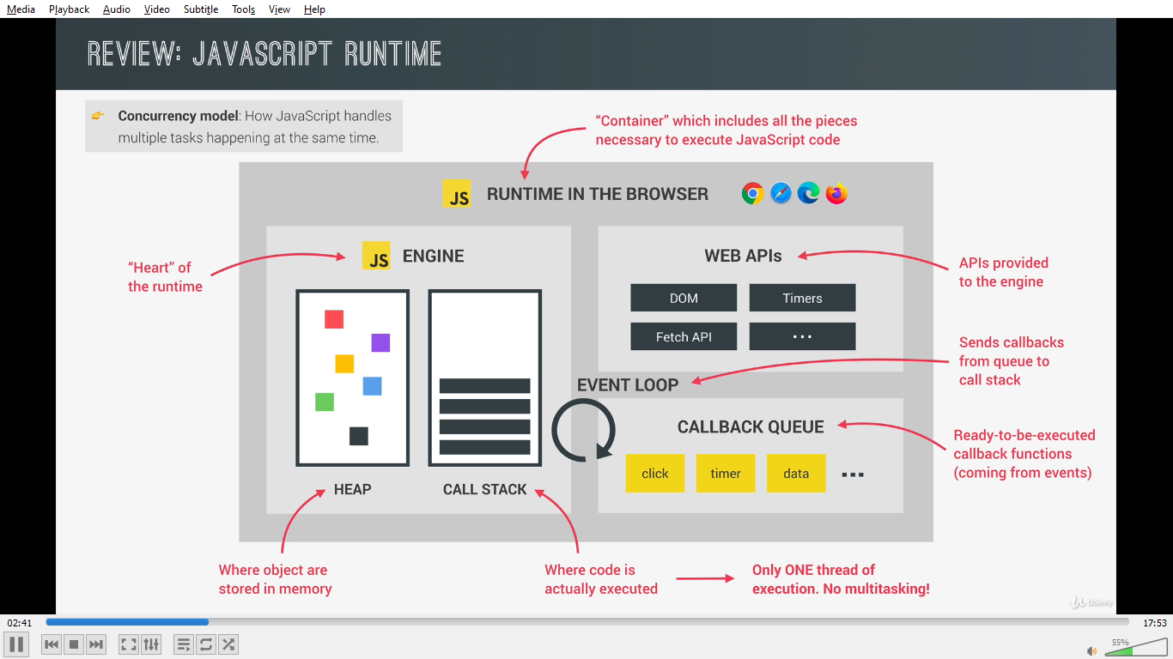
A JS runtime is basically a container which has every thing to execute JS code, The heart of every JS runtime is its engine,
this is where the code is executed and objects are stored in the memory these two thing happen in the call stack and in the heap
as we know tha JS has only one thread of execution it can only do one thing at a time,
We have WEB APIs provided to the engine like DOM timers fetch API geolocation API and so on,
Then we have the call back queue this is the data structure that holds all the ready to be executed call back function that are attached to some event that has occurred
Finally when the call stack is empty the event loop takes the call backs from the call back queue and puts them in the call stack so that it can be executed,
so event loop is the essential piece that makes async behaviour possible in JS
it is the reason why we can have a non-blocking concurrency model in JS,
a concurrency model is how a language handle multiple things at the same time

If there is only on thread of execution in the engine then how can async code be executed in a non-blocking way
Lets suppose that we are selecting an image and then we are setting the source attribute to an image
this will start to load the image asyncly in the back ground.
What is this back ground?
as we know that every thing related to DOM is not the part of JS but of the WEB Apis so its in the web apis environment that where the asynchronous task related to the DOM will run and same is true for timers AJAX calls and all other async task,
if they will run in the call stack it will block the code
If we need to do something when the image has loading finish then we need to listen to the load event and pass the call back function, In practice this means to register the call back in the web api exactly where the async task is running,
the call back stays there until the async operation is finished,
if suppose we make an ajax call in the in the code this will also run in the web api environment and if and .then method’s call back will also get registered in the same web api environment,
And suppose with this we have executed all the top level code all the code that is not inside any callback function in a synchronous way.
Lets say that the image has finished loading and the load event is emitted on that image what happens next is that the call back for this event is placed in the call back queue which is an ordered list of all the call backs which are in line to be executed
the new call back goes to the end of the queue and when it turns come it will finally run,
Call back queue also contains the callback coming from the dom events like clicks key presses etc they are not async behaviour but the still use the call back queue to run their attached call back
Event loop looks into the call stack and determines whether the callstack is empty or not except for the global context, and then if the call stack only has the global context then it will take the first call back from the call back queue and put it on to the call stack to be executed this is called an event loop tick
Now lets say that data form the ajax call has finally arrived now the call back registered from the promises do not go in the call back queue instead the call back from promises have a special queue for themselves which is the micro task queue, microtask queue has the priority over the call back queue so at the end of of an event loop tick the event loop checks if there are any call backs in the micro task queue it will run all of them before it will run any of the regular call backs from the call back queue
If microtask queue has any of the call back it will take one and place it in the call stack

Async Awiat
What you need to understand is that async/await does not make your code run synchronously, but let's you write it as if it is:

In short: The function with async in front of it is literally executed asynchronously, hence the keyword "async". And the "await" keyword wil make that line that uses it inside this async function wait for a promise during its execution. So although the line waits, the whole function is still run asynchronously, unless the caller of that function also 'awaits'...

More elaborately explained: When you put async in front of a function, what is actually does is make it return a promise with whatever that function returns inside it. The function runs asynchronously and when the return statement is executed the promise resolves the returning value.

Meaning, in your code:

const getResult = async () => {
return await myFun();
}
The function "getResult()" will return a Promise which will resolve once it has finished executing. So the lines inside the getResult() function are run asynchronously, unless you tell the function calling getResult() to 'await' for it as well. Inside the getResult() function you may say it must await the result, which makes the execution of getResult() wait for it to resolve the promise, but the caller of getResult() will not wait unless you also tell the caller to 'await'.

So a solution would be calling either:

getResult().then(result=>{console.log(result)})
Or when using in another function you can simply use 'await' again

async callingFunction(){
console.log(await(getResult());
}

async function is a function that has key word async in it’s declaration. This function will not run in the JS engine but inside web API’s inside the browser in the background.
It means the code inside of it will run in the web API’s when this function is done is automatically returns a promise.
Inside an async function we can have one or more await statements where we return the promise.
We can await the result of a promise with await keyword..
Await will stop the code execution at this point of the function until the promise is fulfilled. Until the data has been fetched

The question is isn’t stoping the code blocking the execution.
The answer is actually no because stopping execution in an async function is a actually not a problem because this function is not in the call stack it is running asynchronously in the background therefore it is not blocking the main thread of the execution. So it is not blocking the call stack.
In fact that’s what is so special about async await

It makes our code look like asynchronous code while behind the scene everything is asynchronous.

As soon as the promise is resolved then the value of whole await expression is gonna be the resolve value of our promise.
We can simply store that into a variable

Error handling in async await
With async await we cant use catch method because we cant really attach any where.
Instead we use some thing called a try catch statement.

We can wrap all our code in a try block. Javascript will then basically try to execute that code. Just like normal code. After the try block we can have a catch block which will have access to whatever error occurs
Inside the try block where we can do something with that error usually show an alert to the user about the error.

await vs return vs return await

When writing async functions, there are differences between await vs return vs return await, and picking the right one is important.

Let's start with this async function:

async function waitAndMaybeReject() {
// Wait one second
await new Promise(r => setTimeout(r, 1000));
// Toss a coin
const isHeads = Boolean(Math.round(Math.random()));

if (isHeads) return 'yay';
throw Error('Boo!');
}
This returns a promise that waits a second, then has a 50/50 chance of fulfilling with "yay" or rejecting with an error. Let's use it in a few subtlety different ways:

Just calling
async function foo() {
try {
waitAndMaybeReject();
}
catch (e) {
return 'caught';
}
}
Here, if you call foo, the returned promise will always fulfill with undefined, without waiting.

Since we don't await or return the result of waitAndMaybeReject(), we don't react to it in any way. Code like this is usually a mistake.

Awaiting
async function foo() {
try {
await waitAndMaybeReject();
}
catch (e) {
return 'caught';
}
}
Here, if you call foo, the returned promise will always wait one second, then either fulfill with undefined, or fulfill with "caught".

Because we await the result of waitAndMaybeReject(), its rejection will be turned into a throw, and our catch block will execute. However, if waitAndMaybeReject() fulfills, we don't do anything with the value.

Returning
async function foo() {
try {
return waitAndMaybeReject();
}
catch (e) {
return 'caught';
}
}
Here, if you call foo, the returned promise will always wait one second, then either fulfill with "yay", or reject with Error('Boo!').

By returning waitAndMaybeReject(), we're deferring to its result, so our catch block never runs.

Return-awaiting
The thing you want in try/catch blocks, is return await:

async function foo() {
try {
return await waitAndMaybeReject();
}
catch (e) {
return 'caught';
}
}
Here, if you call foo, the returned promise will always wait one second, then either fulfill with "yay", or fulfill with "caught".

Because we await the result of waitAndMaybeReject(), its rejection will be turned into a throw, and our catch block will execute. If waitAndMaybeReject() fulfills, we return its result.

If the above seems confusing, it might be easier to think of it as two separate steps:

async function foo() {
try {
// Wait for the result of waitAndMaybeReject() to settle,
// and assign the fulfilled value to fulfilledValue:
const fulfilledValue = await waitAndMaybeReject();
// If the result of waitAndMaybeReject() rejects, our code
// throws, and we jump to the catch block.
// Otherwise, this block continues to run:
return fulfilledValue;
}
catch (e) {
return 'caught';
}
}
Note: Outside of try/catch blocks, return await is redundant. There's even an ESLint rule to detect it, but it allows it in try/catch.

View this page on GitHub

- angular vs react difference 2. what is virtual dom and incremental dom 3. what is data binding and dependency injections 4. What are pure components 5. what is controlled components & uncontrolled components 6. what is ES6 new updates 7. Arrow functions 8. Redux functioning 9. Life cycle methods in react(Both component & functional ones) 10.What are promises? 11.Where will we use api calls in redux process ? 12.What are the difference between GET /POST /PUT/PATCH/DELETE? 13.How to send data using components from parent to child & child to parent(using callback or setState)? 14.What is callback functions? 15.What is array destrcuturing ? 16.Can we combine two arrays using any es6 operators ? ans: Spread Operators 17.HTML vs HTML 5 ? 18.Localstorage , session storage & cookies ? 19.GIT Basics 20.SDLC lifecycle methods basics

Json vs object
An Object literal is when you declare an Object in JavaScript code which is a variable that stores data in key-value pairs, while JSON stands for JavaScript Object Notation and it's a language-agnostic format for storing and transferring data that is based on JavaScript Objects.
JSON is a string representation of an object. It is an interoperable serialization format. It is not tied only to javascript.

Object.seal
- It prevents adding and/or removing properties from the sealed object; using delete will return false
- It makes every existing property non-configurable: they cannot be converted from 'data descriptors' to 'accessor descriptors' (and vice versa), and no attribute of accessor descriptors can be modified at all (whereas data descriptors can change their writable attribute, and their value attribute if writeable is true).
- Can throw a TypeError when attempting to modify the value of the sealed object itself (most commonly in strict mode)
Object.freeze
- Exactly what Object.seal does, plus:
- It prevents modifying any existing properties
Neither one affects 'deep'/grandchildren objects. E.g., if obj is frozen, obj.el can’t be reassigned, but the value of obj.el could be modified, e.g. obj.el.id can be changed.
Generator-Function : A generator-function is defined like a normal function, but whenever it needs to generate a value, it does so with the yield keyword rather than return. The yield statement suspends function’s execution and sends a value back to caller, but retains enough state to enable function to resume where it is left off. When resumed, the function continues execution immediately after the last yield run.
Syntax :
// An example of generator function
function* gen(){
yield 1;
yield 2;
...
...
}
Generator-Object : Generator functions return a generator object. Generator objects are used either by calling the next method on the generator object or using the generator object in a “for of” loop (as shown in the above program)
The Generator object is returned by a generating function and it conforms to both the iterable protocol and the iterator protocol.

Why is JS a dynamic language
Because data types of the variable can change during run time and JS will not complain about it
it means if suppose we declare a variable using var or let and first we initialize it to a number later in the code we can assign it to string

How does JS determine data type
By looking at the values during the run time, if suppose const x = 100 the data type of x will be a number

How can we determine data type of the variable in JS
typeof function which takes the variable and return the data type

How many data types are there in JS
There are 8 data types in JS 7 are primitive and rest are objects,
in primitive we have string , number, boolean, null, undefined ,symbol, bigInt,

Explain undefined datatype
Undefined means the variable has been declared but no value has been assigned to it,
What is null
Null is data type which indicates intentional absence of data, it is not an empty string it is not 0 it is null

null vs undefined
If the variable has been created but the value is not assigned then its undefined where as if we assign its value to null it is null it is neither 0 nor empty string,

Explain Javascript Hoisting
It’s a mechanism where variable and function declaration are moved to the top of the scope before the code execution, if we use var before declaration it will return undefined where as let and const will return reference error as those variables are not hoisted ,

Global variables
Are accessible through the document,

What happens when we declare the variable without var keyword
When we declare the variable without var key word the variable becomes global,

Use strict
Strictly checks if the variables are declared using var keyword or let keyword, if we declare a variable without var or let it will throw an exception,

How can we avoid global variable issues,
We can create global variable using namespace called global, we can apply closure and module pattern

Why do we need closures?
It creates self-contained functions,
we can return the functions we want by using functions inside function and return the methods that we want, and we can have functions that are private to the closure and with these to fundamental advantages we can create,
What is iffe
Iffe stands for immediately invoked function expressions, its is an anonymous function and it is self invoking , we use two round brackets to immediately invoke them,

Name collision
We get name collision when we use same variable name in same context, iife can solve the name collision problem

Explain design patterns what are the most used design patterns in JS
Design patterns are tested solution for architecture problems, it means how to organize our code, the most used design pattern in JS is module pattern,
it help us to crate self contained independent components name spaces that helps structure code,
it provides encapsulation means we can control what we want to make public and what not
by using iffe we can create logical namespaces and closures help in encapsulation for example we can expose customer invoices but we can hide customer validation

Ways of creating JS objects
Object literal object.create constructor and classes,
Object.create can be used to crate instance of object
Constructor functions are can be used to create classes
And class keyword can be used to create classes we can define the properties and we can create the instance of the class
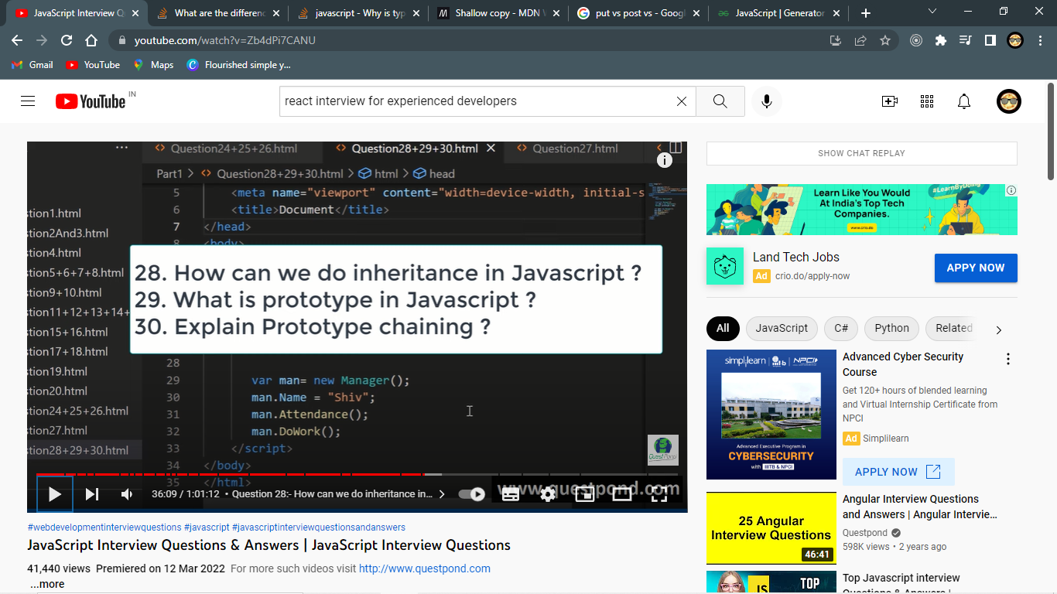
Inheritance in JS is done by using prototype object, in JS inheritance is object based and not class based
The child.prototype will points towards the parent object, every thing that belongs to the parent will be accessible by the parent but child can also have some extra properties and methods and child can override which is something in the parent
Every object by default in JS has a prototype object
prototype object creates a linklist it means child object will have a linklist object of the parent
and that is why it is termed as prototype chaining, it means if we want to access a property or a method in child it will first try to search that property or the method in the current object if it does not get it will go inside the prototype and see if it is present there it will go to the parent object and see if it is present there if it is not available there it will look in the parents prototype and so on.

Let
Let key word was introduced in ES6 and it is used to create block level scoped local variable, block level means from whichever curly bracket inside which we have declared the let is the scope of the variable

With var the variables are hoisted but initialized with value undefined but with let it is not initialzed

TDZ
It is a period or state of the variable when the variables are named into the memory but they are not declared and initialized with the value

Let vs var (scoping and initialization)
Variables declared with the var keyword are scoped to the immediate function body, while variables declared with let are scoped to the immediate enclosing block
in the hoisting phase both the variables are hoisted but in case of var variable will be initialized with the value undefined in case of let the variables will be not initialized with any value they stay in TDZ

What is React?
React is an open-source front-end JavaScript library that is used for building user interfaces, especially for single-page applications. It is used for handling view layer for web and mobile apps. React was created by Jordan Walke, a software engineer working for Facebook. React was first deployed on Facebook's News Feed in 2011 and on Instagram in 2012.

What are the major features of React?
The major features of React are:
- It uses VirtualDOM instead of RealDOM considering that RealDOM manipulations are expensive.
- Supports server-side rendering.
- Follows Unidirectional data flow or data binding.
- Uses reusable/composable UI components to develop the view.

What is JSX?
JSX is a XML-like syntax extension to ECMAScript (the acronym stands for JavaScript XML). Basically it just provides syntactic sugar for the React.createElement() function, giving us expressiveness of JavaScript along with HTML like template syntax.
In the example below text inside <h1> tag is returned as JavaScript function to the render function.
class App extends React.Component {
render() {
return(
<div>
<h1>{'Welcome to React world!'}</h1>
</div>
)
}
}

What is the difference between Element and Component?
An Element is a plain object describing what you want to appear on the screen in terms of the DOM nodes or other components. Elements can contain other Elements in their props. Creating a React element is cheap. Once an element is created, it is never mutated.
The object representation of React Element would be as follows:
const element = React.createElement(
'div',
{id: 'login-btn'},
'Login'
)
The above React.createElement() function returns an object:
{
type: 'div',
props: {
children: 'Login',
id: 'login-btn'
}
}
And finally it renders to the DOM using ReactDOM.render():
<div id='login-btn'>Login</div>
Whereas a component can be declared in several different ways. It can be a class with a render() method or it can be defined as a function. In either case, it takes props as an input, and returns a JSX tree as the output:
const Button = ({ onLogin }) =>
<div id={'login-btn'} onClick={onLogin}>Login</div>
Then JSX gets transpiled to a React.createElement() function tree:
const Button = ({ onLogin }) => React.createElement(
'div',
{ id: 'login-btn', onClick: onLogin },
'Login'
)

What are Pure Components?
React.PureComponent is exactly the same as React.Component except that it handles the shouldComponentUpdate() method for you. When props or state changes, PureComponent will do a shallow comparison on both props and state. Component on the other hand won't compare current props and state to next out of the box. Thus, the component will re-render by default whenever shouldComponentUpdate is called.

What is state in React?
State of a component is an object that holds some information that may change over the lifetime of the component.

What are props in React?
Props are inputs to components. They are single values or objects containing a set of values that are passed to components on creation using a naming convention similar to HTML-tag attributes. They are data passed down from a parent component to a child component.
The primary purpose of props in React is to provide following component functionality:
- Pass custom data to your component.
- Trigger state changes.
- Use via this.props.reactProp inside component's render() method.

Why should we not update the state directly?
If you try to update the state directly then it won't re-render the component.
//Wrong
this.state.message = 'Hello world'
Instead use setState() method. It schedules an update to a component's state object. When state changes, the component responds by re-rendering.
//Correct
this.setState({ message: 'Hello World' })
Note: You can directly assign to the state object either in constructor or using latest javascript's class field declaration syntax.

What is the purpose of callback function as an argument of setState()?
The callback function is invoked when setState finished and the component gets rendered. Since setState() is asynchronous the callback function is used for any post action.
Note: It is recommended to use lifecycle method rather than this callback function.

What is the difference between HTML and React event handling?
Below are some of the main differences between HTML and React event handling,
  - In HTML, the event name usually represents in lowercase as a convention:
<button onclick='activateLasers()'>
Whereas in React it follows camelCase convention:
<button onClick={activateLasers}>
  - In HTML, you can return false to prevent default behavior:
<a href='#' onclick='console.log("The link was clicked."); return false;' />
Whereas in React you must call preventDefault() explicitly:
function handleClick(event) {
event.preventDefault()
console.log('The link was clicked.')
}
  - In HTML, you need to invoke the function by appending () Whereas in react you should not append () with the function name. (refer "activateLasers" function in the first point for example)

How to bind methods or event handlers in JSX callbacks?
There are 3 possible ways to achieve this:
  - Binding in Constructor: In JavaScript classes, the methods are not bound by default. The same thing applies for React event handlers defined as class methods. Normally we bind them in constructor.
  - class Foo extends Component {
  - constructor(props) {
  - super(props);
  - this.handleClick = this.handleClick.bind(this);
  - }
  - handleClick() {
  - console.log('Click happened');
  - }
  - render() {
  - return <button onClick={this.handleClick}>Click Me</button>;
  - }
}
  - Public class fields syntax: If you don't like to use bind approach then public class fields syntax can be used to correctly bind callbacks.
  - handleClick = () => {
  - console.log('this is:', this)
}
<button onClick={this.handleClick}>
{'Click me'}
</button>
  - Arrow functions in callbacks: You can use arrow functions directly in the callbacks.
  - handleClick() {
  - console.log('Click happened');
  - }
  - render() {
  - return <button onClick={() => this.handleClick()}>Click Me</button>;
}
Note: If the callback is passed as prop to child components, those components might do an extra re-rendering. In those cases, it is preferred to go with .bind() or public class fields syntax approach considering performance.

What are synthetic events in React?
SyntheticEvent is a cross-browser wrapper around the browser's native event. Its API is same as the browser's native event, including stopPropagation() and preventDefault(), except the events work identically across all browsers.

What are inline conditional expressions?
You can use either if statements or ternary expressions which are available from JS to conditionally render expressions. Apart from these approaches, you can also embed any expressions in JSX by wrapping them in curly braces and then followed by JS logical operator &&.

What are forward refs?
Ref forwarding is a feature that lets some components take a ref they receive, and pass it further down to a child.
const ButtonElement = React.forwardRef((props, ref) => (
<button ref={ref} className="CustomButton">
{props.children}
</button>
));

// Create ref to the DOM button:
const ref = React.createRef();
<ButtonElement ref={ref}>{'Forward Ref'}</ButtonElement>

What is the difference between Shadow DOM and Virtual DOM?
The Shadow DOM is a browser technology designed primarily for scoping variables and CSS in web components. The Virtual DOM is a concept implemented by libraries in JavaScript on top of browser APIs.

What is React Fiber?
Fiber is the new reconciliation engine or reimplementation of core algorithm in React v16. The goal of React Fiber is to increase its suitability for areas like animation, layout, gestures, ability to pause, abort, or reuse work and assign priority to different types of updates;

What is the main goal of React Fiber?
The goal of React Fiber is to increase its suitability for areas like animation, layout, and gestures. Its headline feature is incremental rendering: the ability to split rendering work into chunks and spread it out over multiple frames.
from documentation
Its main goals are:
  - Ability to split interruptible work in chunks.
  - Ability to prioritize, rebase and reuse work in progress.
  - Ability to yield back and forth between parents and children to support layout in React.
  - Ability to return multiple elements from render().
  - Better support for error boundaries.

What is the difference between createElement and cloneElement?
JSX elements will be transpiled to React.createElement() functions to create React elements which are going to be used for the object representation of UI. Whereas cloneElement is used to clone an element and pass it new props.

What is context?
Context provides a way to pass data through the component tree without having to pass props down manually at every level.
For example, authenticated users, locale preferences, UI themes need to be accessed in the application by many components.
const {Provider, Consumer} = React.createContext(defaultValue)

What would be the common mistake of function being called every time the component renders?
You need to make sure that function is not being called while passing the function as a parameter.
render() {
// Wrong: handleClick is called instead of passed as a reference!
return <button onClick={this.handleClick()}>{'Click Me'}</button>
}
Instead, pass the function itself without parenthesis:
render() {
// Correct: handleClick is passed as a reference!
return <button onClick={this.handleClick}>{'Click Me'}</button>
}

What are fragments?
It's a common pattern in React which is used for a component to return multiple elements. Fragments let you group a list of children without adding extra nodes to the DOM.

Why fragments are better than container divs?
Below are the list of reasons,
  - Fragments are a bit faster and use less memory by not creating an extra DOM node. This only has a real benefit on very large and deep trees.
  - Some CSS mechanisms like Flexbox and CSS Grid have a special parent-child relationships, and adding divs in the middle makes it hard to keep the desired layout.
  - The DOM Inspector is less cluttered.

What are stateless components?
If the behaviour is independent of its state then it can be a stateless component. You can use either a function or a class for creating stateless components. But unless you need to use a lifecycle hook in your components, you should go for function components. There are a lot of benefits if you decide to use function components here; they are easy to write, understand, and test, a little faster, and you can avoid the this keyword altogether.

What are stateful components?
If the behaviour of a component is dependent on the state of the component then it can be termed as stateful component. These stateful components are always class components and have a state that gets initialized in the constructor.
Hooks let you use state and other React features without writing classes.
The Equivalent Functional Component

What are the advantages of React?
Below are the list of main advantages of React,
  - Increases the application's performance with Virtual DOM.
  - JSX makes code easy to read and write.
  - It renders both on client and server side (SSR).
  - Easy to integrate with frameworks (Angular, Backbone) since it is only a view library.
  - Easy to write unit and integration tests with tools such as Jest.

What are the limitations of React?
  - React is just a view library, not a full framework.
  - There is a learning curve for beginners who are new to web development.
  - Integrating React into a traditional MVC framework requires some additional configuration.
  - The code complexity increases with inline templating and JSX.
  - Too many smaller components leading to over engineering or boilerplate.

What are error boundaries in React v16?
Error boundaries are components that catch JavaScript errors anywhere in their child component tree, log those errors, and display a fallback UI instead of the component tree that crashed.

What is the use of react-dom package?
The react-dom package provides DOM-specific methods that can be used at the top level of your app. Most of the components are not required to use this module. Some of the methods of this package are:
  - render()
  - hydrate()
  - unmountComponentAtNode()
  - findDOMNode()
  - createPortal()

What is ReactDOMServer?
The ReactDOMServer object enables you to render components to static markup (typically used on node server). This object is mainly used for server-side rendering (SSR). The following methods can be used in both the server and browser environments:
  - renderToString()
  - renderToStaticMarkup()
For example, you generally run a Node-based web server like Express, Hapi, or Koa, and you call renderToString to render your root component to a string, which you then send as response.
// using Express
import { renderToString } from 'react-dom/server'
import MyPage from './MyPage'

app.get('/', (req, res) => {
res.write('<!DOCTYPE html><html><head><title>My Page</title></head><body>')
res.write('<div id="content">')
res.write(renderToString(<MyPage/>))
res.write('</div></body></html>')
res.end()
})

What will happen if you use setState() in constructor?
When you use setState(), then apart from assigning to the object state React also re-renders the component and all its children. You would get error like this: Can only update a mounted or mounting component. So we need to use this.state to initialize variables inside constructor.

Is it good to use setState() in componentWillMount() method?
Yes, it is safe to use setState() inside componentWillMount() method. But at the same it is recommended to avoid async initialization in componentWillMount() lifecycle method. componentWillMount() is invoked immediately before mounting occurs. It is called before render(), therefore setting state in this method will not trigger a re-render. Avoid introducing any side-effects or subscriptions in this method. We need to make sure async calls for component initialization happened in componentDidMount() instead of componentWillMount().
componentDidMount() {
axios.get(`api/todos`)
.then((result) => {
this.setState({
messages: [...result.data]
})
})
}

What will happen if you use props in initial state?
If the props on the component are changed without the component being refreshed, the new prop value will never be displayed because the constructor function will never update the current state of the component. The initialization of state from props only runs when the component is first created.
The below component won't display the updated input value:
class MyComponent extends React.Component {
constructor(props) {
super(props)

this.state = {
records: [],
inputValue: this.props.inputValue
};
}

render() {
return <div>{this.state.inputValue}</div>
}
}
Using props inside render method will update the value:
class MyComponent extends React.Component {
constructor(props) {
super(props)

this.state = {
record: []
}
}

render() {
return <div>{this.props.inputValue}</div>
}
}

Why we need to be careful when spreading props on DOM elements?
When we spread props we run into the risk of adding unknown HTML attributes, which is a bad practice. Instead we can use prop destructuring with ...rest operator, so it will add only required props.
For example,
const ComponentA = () =>
<ComponentB isDisplay={true} className={'componentStyle'} />

const ComponentB = ({ isDisplay, ...domProps }) =>
<div {...domProps}>{'ComponentB'}</div>

How you use decorators in React?
You can decorate your class components, which is the same as passing the component into a function. Decorators are flexible and readable way of modifying component functionality.
@setTitle('Profile')
class Profile extends React.Component {
//....
}

/*
title is a string that will be set as a document title
WrappedComponent is what our decorator will receive when
put directly above a component class as seen in the example above
*/
const setTitle = (title) => (WrappedComponent) => {
return class extends React.Component {
componentDidMount() {
document.title = title
}

render() {
return <WrappedComponent {...this.props} />
}
}
}

How do you memoize a component?
There are memoize libraries available which can be used on function components.
For example moize library can memoize the component in another component.
import moize from 'moize'
import Component from './components/Component' // this module exports a non-memoized component

const MemoizedFoo = moize.react(Component)

const Consumer = () => {
<div>
{'I will memoize the following entry:'}
<MemoizedFoo/>
</div>
}
Update: Since React v16.6.0, we have a React.memo. It provides a higher order component which memoizes component unless the props change. To use it, simply wrap the component using React.memo before you use it.
const MemoComponent = React.memo(function MemoComponent(props) {
/* render using props */
});
OR
export default React.memo(MyFunctionComponent);

How to enable production mode in React?
You should use Webpack's DefinePlugin method to set NODE_ENV to production, by which it strip out things like propType validation and extra warnings. Apart from this, if you minify the code, for example, Uglify's dead-code elimination to strip out development only code and comments, it will drastically reduce the size of your bundle.

What is CRA and its benefits?
The create-react-app CLI tool allows you to quickly create & run React applications with no configuration step.
Let's create Todo App using CRA:
# Installation
$ npm install -g create-react-app

# Create new project
$ create-react-app todo-app
$ cd todo-app

# Build, test and run
$ npm run build
$ npm run test
$ npm start
It includes everything we need to build a React app:
  - React, JSX, ES6, and Flow syntax support.
  - Language extras beyond ES6 like the object spread operator.
  - Autoprefixed CSS, so you don’t need -webkit- or other prefixes.
  - A fast interactive unit test runner with built-in support for coverage reporting.
  - A live development server that warns about common mistakes.
  - A build script to bundle JS, CSS, and images for production, with hashes and sourcemaps.

What are the Pointer Events supported in React?
Pointer Events provide a unified way of handling all input events. In the old days we had a mouse and respective event listeners to handle them but nowadays we have many devices which don't correlate to having a mouse, like phones with touch surface or pens. We need to remember that these events will only work in browsers that support the Pointer Events specification.
The following event types are now available in React DOM:
  - onPointerDown
  - onPointerMove
  - onPointerUp
  - onPointerCancel
  - onGotPointerCapture
  - onLostPointerCapture
  - onPointerEnter
  - onPointerLeave
  - onPointerOver
  - onPointerOut

Why should component names start with capital letter?
If you are rendering your component using JSX, the name of that component has to begin with a capital letter otherwise React will throw an error as an unrecognized tag.

How to conditionally apply class attributes?
You shouldn't use curly braces inside quotes because it is going to be evaluated as a string.
<div className="btn-panel {this.props.visible ? 'show' : 'hidden'}">
Instead you need to move curly braces outside (don't forget to include spaces between class names):
<div className={'btn-panel ' + (this.props.visible ? 'show' : 'hidden')}>
Template strings will also work:
<div className={`btn-panel ${this.props.visible ? 'show' : 'hidden'}`}>

What is the difference between React and ReactDOM?
The react package contains React.createElement(), React.Component, React.Children, and other helpers related to elements and component classes. You can think of these as the isomorphic or universal helpers that you need to build components. The react-dom package contains ReactDOM.render(), and in react-dom/server we have server-side rendering support with ReactDOMServer.renderToString() and ReactDOMServer.renderToStaticMarkup().

Why ReactDOM is separated from React?
The React team worked on extracting all DOM-related features into a separate library called ReactDOM. React v0.14 is the first release in which the libraries are split. By looking at some of the packages, react-native, react-art, react-canvas, and react-three, it has become clear that the beauty and essence of React has nothing to do with browsers or the DOM.
To build more environments that React can render to, React team planned to split the main React package into two: react and react-dom. This paves the way to writing components that can be shared between the web version of React and React Native.

What is the difference between setState() and replaceState() methods?
When you use setState() the current and previous states are merged. replaceState() throws out the current state, and replaces it with only what you provide. Usually setState() is used unless you really need to remove all previous keys for some reason. You can also set state to false/null in setState() instead of using replaceState().

How to listen to state changes?
The componentDidUpdate lifecycle method will be called when state changes. You can compare provided state and props values with current state and props to determine if something meaningful changed.
componentDidUpdate(object prevProps, object prevState)

Why you can't update props in React?
The React philosophy is that props should be immutable and top-down. This means that a parent can send any prop values to a child, but the child can't modify received props.

How to use https instead of http in create-react-app?
You just need to use HTTPS=true configuration. You can edit your package.json scripts section:
"scripts": {
"start": "set HTTPS=true && react-scripts start"
}
or just run set HTTPS=true && npm start

What are render props?
Render Props is a simple technique for sharing code between components using a prop whose value is a function. The below component uses render prop which returns a React element.

What is Shallow Renderer in React testing?
Shallow rendering is useful for writing unit test cases in React. It lets you render a component one level deep and assert facts about what its render method returns, without worrying about the behavior of child components, which are not instantiated or rendered.
For example, if you have the following component:
function MyComponent() {
return (
<div>
<span className={'heading'}>{'Title'}</span>
<span className={'description'}>{'Description'}</span>
</div>
)
}
Then you can assert as follows:

What is TestRenderer package in React?
This package provides a renderer that can be used to render components to pure JavaScript objects, without depending on the DOM or a native mobile environment. This package makes it easy to grab a snapshot of the platform view hierarchy (similar to a DOM tree) rendered by a ReactDOM or React Native without using a browser or jsdom.
import TestRenderer from 'react-test-renderer'

const Link = ({page, children}) => <a href={page}>{children}</a>

const testRenderer = TestRenderer.create(
<Link page={'https://www.facebook.com/'}>{'Facebook'}</Link>
)

console.log(testRenderer.toJSON())
// {
// type: 'a',
// props: { href: 'https://www.facebook.com/' },
// children: [ 'Facebook' ]
// }

What is the purpose of ReactTestUtils package?
ReactTestUtils are provided in the with-addons package and allow you to perform actions against a simulated DOM for the purpose of unit testing.

What is Jest?
Jest is a JavaScript unit testing framework created by Facebook based on Jasmine and provides automated mock creation and a jsdom environment. It's often used for testing components.

What are the advantages of Jest over Jasmine?
There are couple of advantages compared to Jasmine:
  - Automatically finds tests to execute in your source code.
  - Automatically mocks dependencies when running your tests.
  - Allows you to test asynchronous code synchronously.
  - Runs your tests with a fake DOM implementation (via jsdom) so that your tests can be run on the command line.
  - Runs tests in parallel processes so that they finish sooner.

Give a simple example of Jest test case
Let's write a test for a function that adds two numbers in sum.js file:
const sum = (a, b) => a + b

export default sum
Create a file named sum.test.js which contains actual test:
import sum from './sum'

test('adds 1 + 2 to equal 3', () => {
expect(sum(1, 2)).toBe(3)
})
And then add the following section to your package.json:
{
"scripts": {
"test": "jest"
}
}
Finally, run yarn test or npm test and Jest will print a result:
$ yarn test
PASS ./sum.test.js
✓ adds 1 + 2 to equal 3 (2ms)

What is flux?
Flux is an application design paradigm used as a replacement for the more traditional MVC pattern. It is not a framework or a library but a new kind of architecture that complements React and the concept of Unidirectional Data Flow. Facebook uses this pattern internally when working with React.
The workflow between dispatcher, stores and views components with distinct inputs and outputs as follows:
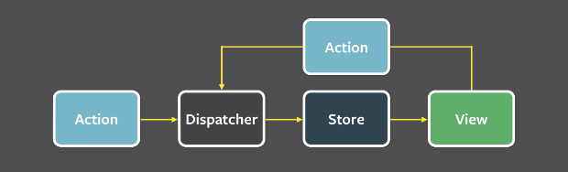

What is the difference between mapStateToProps() and mapDispatchToProps()?
mapStateToProps() is a utility which helps your component get updated state (which is updated by some other components):
const mapStateToProps = (state) => {
return {
todos: getVisibleTodos(state.todos, state.visibilityFilter)
}
}
mapDispatchToProps() is a utility which will help your component to fire an action event (dispatching action which may cause change of application state):
const mapDispatchToProps = (dispatch) => {
return {
onTodoClick: (id) => {
dispatch(toggleTodo(id))
}
}
}
It is recommended to always use the “object shorthand” form for the mapDispatchToProps.
Redux wraps it in another function that looks like (…args) => dispatch(onTodoClick(…args)), and pass that wrapper function as a prop to your component.
const mapDispatchToProps = ({
onTodoClick
})

Can I dispatch an action in reducer?
Dispatching an action within a reducer is an anti-pattern. Your reducer should be without side effects, simply digesting the action payload and returning a new state object. Adding listeners and dispatching actions within the reducer can lead to chained actions and other side effects.

What is the difference between React context and React Redux?
You can use Context in your application directly and is going to be great for passing down data to deeply nested components which what it was designed for.
Whereas Redux is much more powerful and provides a large number of features that the Context API doesn't provide. Also, React Redux uses context internally but it doesn't expose this fact in the public API.

What is the difference between component and container in React Redux?
Component is a class or function component that describes the presentational part of your application.
Container is an informal term for a component that is connected to a Redux store. Containers subscribe to Redux state updates and dispatch actions, and they usually don't render DOM elements; they delegate rendering to presentational child components.

What is the use of the ownProps parameter in mapStateToProps() and mapDispatchToProps()?
If the ownProps parameter is specified, React Redux will pass the props that were passed to the component into your connect functions. So, if you use a connected component:

How to structure Redux top level directories?
Most of the applications has several top-level directories as below:
  - Components: Used for dumb components unaware of Redux.
  - Containers: Used for smart components connected to Redux.
  - Actions: Used for all action creators, where file names correspond to part of the app.
  - Reducers: Used for all reducers, where files name correspond to state key.
  - Store: Used for store initialization.
This structure works well for small and medium size apps.

What is the difference between React and Angular?
Let's see the difference between React and Angular in a table format.
React | Angular
React is a library and has only the View layer | Angular is a framework and has complete MVC functionality
React handles rendering on the server side | AngularJS renders only on the client side but Angular 2 and above renders on the server side
React uses JSX that looks like HTML in JS which can be confusing | Angular follows the template approach for HTML, which makes code shorter and easy to understand
React Native, which is a React type to build mobile applications are faster and more stable | Ionic, Angular's mobile native app is relatively less stable and slower
In React, data flows only in one way and hence debugging is easy | In Angular, data flows both way i.e it has two-way data binding between children and parent and hence debugging is often difficult

How to prevent unnecessary updates using setState?
You can compare the current value of the state with an existing state value and decide whether to rerender the page or not. If the values are the same then you need to return null to stop re-rendering otherwise return the latest state value.
For example, the user profile information is conditionally rendered as follows,
getUserProfile = user => {
const latestAddress = user.address;
this.setState(state => {
if (state.address === latestAddress) {
return null;
} else {
return { title: latestAddress };
}
});
};

What rules need to be followed for hooks?
You need to follow two rules in order to use hooks,
  - Call Hooks only at the top level of your react functions. i.e, You shouldn’t call Hooks inside loops, conditions, or nested functions. This will ensure that Hooks are called in the same order each time a component renders and it preserves the state of Hooks between multiple useState and useEffect calls.
  - Call Hooks from React Functions only. i.e, You shouldn’t call Hooks from regular JavaScript functions.

How to ensure hooks followed the rules in your project?
React team released an ESLint plugin called eslint-plugin-react-hooks that enforces these two rules. You can add this plugin to your project using the below command,

What are the differences between Flux and Redux?
Flux | Redux
State is mutable | State is immutable
The Store contains both state and change logic | The Store and change logic are separate
There are multiple stores exist | There is only one store exist
All the stores are disconnected and flat | Single store with hierarchical reducers
It has a singleton dispatcher | There is no concept of dispatcher
React components subscribe to the store | Container components uses connect function

What are default props?
The defaultProps are defined as a property on the component class to set the default props for the class. This is used for undefined props, but not for null props.
For example, let us create color default prop for the button component,

Why should not call setState in componentWillUnmount?
You should not call setState() in componentWillUnmount() because once a component instance is unmounted, it will never be mounted again.

What are the methods invoked during error handling?
Below methods are called when there is an error during rendering, in a lifecycle method, or in the constructor of any child component.
  - static getDerivedStateFromError()
  - componentDidCatch()

What is code-splitting?
Code-Splitting is a feature supported by bundlers like Webpack and Browserify which can create multiple bundles that can be dynamically loaded at runtime. The react project supports code splitting via dynamic import() feature.
For example, in the below code snippets, it will make moduleA.js and all its unique dependencies as a separate chunk that only loads after the user clicks the 'Load' button. moduleA.js

Does React support all HTML attributes?
As of React 16, both standard or custom DOM attributes are fully supported.

What are the limitations with HOCs?
Higher-order components come with a few caveats apart from its benefits. Below are the few listed in an order,
  - Don’t use HOCs inside the render method: It is not recommended to apply a HOC to a component within the render method of a component.
  - render() {
  - // A new version of EnhancedComponent is created on every render
  - // EnhancedComponent1 !== EnhancedComponent2
  - const EnhancedComponent = enhance(MyComponent);
  - // That causes the entire subtree to unmount/remount each time!
  - return <EnhancedComponent />;
}
The above code impacts on performance by remounting a component that causes the state of that component and all of its children to be lost. Instead, apply HOCs outside the component definition so that the resulting component is created only once.
  - Static methods must be copied over: When you apply a HOC to a component the new component does not have any of the static methods of the original component
  - // Define a static method
  - WrappedComponent.staticMethod = function() {/*...*/}
  - // Now apply a HOC
  - const EnhancedComponent = enhance(WrappedComponent);

  - // The enhanced component has no static method
typeof EnhancedComponent.staticMethod === 'undefined' // true
You can overcome this by copying the methods onto the container before returning it,
function enhance(WrappedComponent) {
class Enhance extends React.Component {/*...*/}
// Must know exactly which method(s) to copy :(
Enhance.staticMethod = WrappedComponent.staticMethod;
return Enhance;
}
  - Refs aren’t passed through: For HOCs you need to pass through all props to the wrapped component but this does not work for refs. This is because ref is not really a prop similar to key. In this case you need to use the React.forwardRef API

What is the popular choice for form handling?
Formik is a form library for react which provides solutions such as validation, keeping track of the visited fields, and handling form submission.
In detail, You can categorize them as follows,
  - Getting values in and out of form state
  - Validation and error messages
  - Handling form submission
It is used to create a scalable, performant, form helper with a minimal API to solve annoying stuff.

What are the advantages of formik over redux form library?
Below are the main reasons to recommend formik over redux form library,
  - The form state is inherently short-term and local, so tracking it in Redux (or any kind of Flux library) is unnecessary.
  - Redux-Form calls your entire top-level Redux reducer multiple times ON EVERY SINGLE KEYSTROKE. This way it increases input latency for large apps.
  - Redux-Form is 22.5 kB minified gzipped whereas Formik is 12.7 kB

Why are you not required to use inheritance?
In React, it is recommended to use composition over inheritance to reuse code between components. Both Props and composition give you all the flexibility you need to customize a component’s look and behavior explicitly and safely. Whereas, If you want to reuse non-UI functionality between components, it is suggested to extract it into a separate JavaScript module. Later components import it and use that function, object, or class, without extending it.

What is dynamic import?
You can achieve code-splitting in your app using dynamic import. Let's take an example of addition,
  - Normal Import
import { add } from './math';
console.log(add(10, 20));
  - Dynamic Import
import("./math").then(math => {
console.log(math.add(10, 20));
});

What is suspense component?
If the module containing the dynamic import is not yet loaded by the time parent component renders, you must show some fallback content while you’re waiting for it to load using a loading indicator. This can be done using Suspense component.
For example, the below code uses suspense component,
const OtherComponent = React.lazy(() => import('./OtherComponent'));

function MyComponent() {
return (
<div>
<Suspense fallback={<div>Loading...</div>}>
<OtherComponent />
</Suspense>
</div>
);
}
As mentioned in the above code, Suspense is wrapped above the lazy component.

What is route based code splitting?
One of the best place to do code splitting is with routes. The entire page is going to re-render at once so users are unlikely to interact with other elements in the page at the same time. Due to this, the user experience won't be disturbed.
Let us take an example of route based website using libraries like React Router with React.lazy,
import { BrowserRouter as Router, Route, Switch } from 'react-router-dom';
import React, { Suspense, lazy } from 'react';

const Home = lazy(() => import('./routes/Home'));
const About = lazy(() => import('./routes/About'));

const App = () => (
<Router>
<Suspense fallback={<div>Loading...</div>}>
<Switch>
<Route exact path="/" component={Home}/>
<Route path="/about" component={About}/>
</Switch>
</Suspense>
</Router>
);
In the above code, the code splitting will happen at each route level.

Is it possible to use react without JSX?
Yes, JSX is not mandatory for using React. Actually it is convenient when you don’t want to set up compilation in your build environment. Each JSX element is just syntactic sugar for calling React.createElement(component, props, ...children).

When do you need to use refs?
  - Managing focus, text selection, or media playback.
  - Triggering imperative animations.
  - Integrating with third-party DOM libraries.

What is diffing algorithm?
React needs to use algorithms to find out how to efficiently update the UI to match the most recent tree. The diffing algorithms is generating the minimum number of operations to transform one tree into another. However, the algorithms have a complexity in the order of O(n3) where n is the number of elements in the tree.
In this case, displaying 1000 elements would require in the order of one billion comparisons. This is far too expensive. Instead, React implements a heuristic O(n) algorithm based on two assumptions:
  - Two elements of different types will produce different trees.
  - The developer can hint at which child elements may be stable across different renders with a key prop.

What are the rules covered by diffing algorithm?
When diffing two trees, React first compares the two root elements. The behavior is different depending on the types of the root elements. It covers the below rules during reconciliation algorithm,
  - Elements Of Different Types: Whenever the root elements have different types, React will tear down the old tree and build the new tree from scratch. For example, elements to , or from to of different types lead a full rebuild.

  - DOM Elements Of The Same Type: When comparing two React DOM elements of the same type, React looks at the attributes of both, keeps the same underlying DOM node, and only updates the changed attributes. Lets take an example with same DOM elements except className attribute,
  - <div className="show" title="ReactJS" />

<div className="hide" title="ReactJS" />
  - Component Elements Of The Same Type: When a component updates, the instance stays the same, so that state is maintained across renders. React updates the props of the underlying component instance to match the new element, and calls componentWillReceiveProps() and componentWillUpdate() on the underlying instance. After that, the render() method is called and the diff algorithm recurses on the previous result and the new result.
  - Recursing On Children: when recursing on the children of a DOM node, React just iterates over both lists of children at the same time and generates a mutation whenever there’s a difference. For example, when adding an element at the end of the children, converting between these two trees works well.
  - <ul>
  - <li>first</li>
  - <li>second</li>
  - </ul>

  - <ul>
  - <li>first</li>
  - <li>second</li>
  - <li>third</li>
</ul>
  - Handling keys: React supports a key attribute. When children have keys, React uses the key to match children in the original tree with children in the subsequent tree. For example, adding a key can make the tree conversion efficient,
<ul>
<li key="2015">Duke</li>
<li key="2016">Villanova</li>
</ul>

<ul>
<li key="2014">Connecticut</li>
<li key="2015">Duke</li>
<li key="2016">Villanova</li>
</ul>

Can you list down top websites or applications using react as front end framework?
Below are the top 10 websites using React as their front-end framework,
  - Facebook
  - Uber
  - Instagram
  - WhatsApp
  - Khan Academy
  - Airbnb
  - Dropbox
  - Flipboard
  - Netflix
  - PayPal

How to fetch data with React Hooks?
The effect hook called useEffect is used to fetch the data with axios from the API and to set the data in the local state of the component with the state hook’s update function.
Let's take an example in which it fetches list of react articles from the API

Is Hooks cover all use cases for classes?
Hooks doesn't cover all use cases of classes but there is a plan to add them soon. Currently there are no Hook equivalents to the uncommon getSnapshotBeforeUpdate and componentDidCatch lifecycles yet.

Why do we use array destructuring (square brackets notation) in useState?
When we declare a state variable with useState, it returns a pair — an array with two items. The first item is the current value, and the second is a function that updates the value. Using [0] and [1] to access them is a bit confusing because they have a specific meaning. This is why we use array destructuring instead.
For example, the array index access would look as follows:
var userStateVariable = useState('userProfile'); // Returns an array pair
var user = userStateVariable[0]; // Access first item
var setUser = userStateVariable[1]; // Access second item
Whereas with array destructuring the variables can be accessed as follows:
const [user, setUser] = useState('userProfile');

What are the sources used for introducing hooks?
Hooks got the ideas from several different sources. Below are some of them,
  - Previous experiments with functional APIs in the react-future repository
  - Community experiments with render prop APIs such as Reactions Component
  - State variables and state cells in DisplayScript.
  - Subscriptions in Rx.
  - Reducer components in ReasonReact.

Do browsers understand JSX code?
No, browsers can't understand JSX code. You need a transpiler to convert your JSX to regular Javascript that browsers can understand. The most widely used transpiler right now is Babel.

Describe about data flow in react?
React implements one-way reactive data flow using props which reduce boilerplate and is easier to understand than traditional two-way data binding.

What is react scripts?
The react-scripts package is a set of scripts from the create-react-app starter pack which helps you kick off projects without configuring. The react-scripts start command sets up the development environment and starts a server, as well as hot module reloading.

What is Concurrent Rendering?
The Concurrent rendering makes React apps to be more responsive by rendering component trees without blocking the main UI thread. It allows React to interrupt a long-running render to handle a high-priority event. i.e, When you enabled concurrent Mode, React will keep an eye on other tasks that need to be done, and if there's something with a higher priority it will pause what it is currently rendering and let the other task finish first. You can enable this in two ways,
// 1. Part of an app by wrapping with ConcurrentMode
<React.unstable_ConcurrentMode>
<Something />
</React.unstable_ConcurrentMode>

// 2. Whole app using createRoot
ReactDOM.unstable_createRoot(domNode).render(<App />);

What is the difference between async mode and concurrent mode?
Both refers the same thing. Previously concurrent Mode being referred to as "Async Mode" by React team. The name has been changed to highlight React’s ability to perform work on different priority levels. So it avoids the confusion from other approaches to Async Rendering.

Can I use javascript urls in react16.9?
Yes, you can use javascript: URLs but it will log a warning in the console. Because URLs starting with javascript: are dangerous by including unsanitized output in a tag like <a href> and create a security hole.

What is state mutation and how to prevent it?
State mutation happens when you try to update the state of a component without actually using setState function. This can happen when you are trying to do some computations using a state variable and unknowingly save the result in the same state variable. This is the main reason why it is advised to return new instances of state variables from the reducers by using Object.assign({}, ...) or spread syntax.
This can cause unknown issues in the UI as the value of the state variable got updated without telling React to check what all components were being affected from this update and it can cause UI bugs.

What is the difference between useState and useRef hook?
  - useState causes components to re-render after state updates whereas useRef doesn’t cause a component to re-render when the value or state changes. Essentially, useRef is like a “box” that can hold a mutable value in its (.current) property.
  - useState allows us to update the state inside components. While useRef allows refrencing DOM elements.

